Training and Development Centre, BGTH – Accessibility Photos
Please be aware that there is no lift access to the first floor and no disabled toilet.
Front Door
- To open the door, you pull.
- To exit the door, you push.
- It is a double door (left side is locked).
- There is a bell/buzzer to press on the right hand side. Please press to be allowed into the building.
- The height of the door is 77 inches / 195.58cm.
- The width of the door is 66.5 inches / 168.91cm.
- There is a slight ramp to assist visitors and staff if needed.

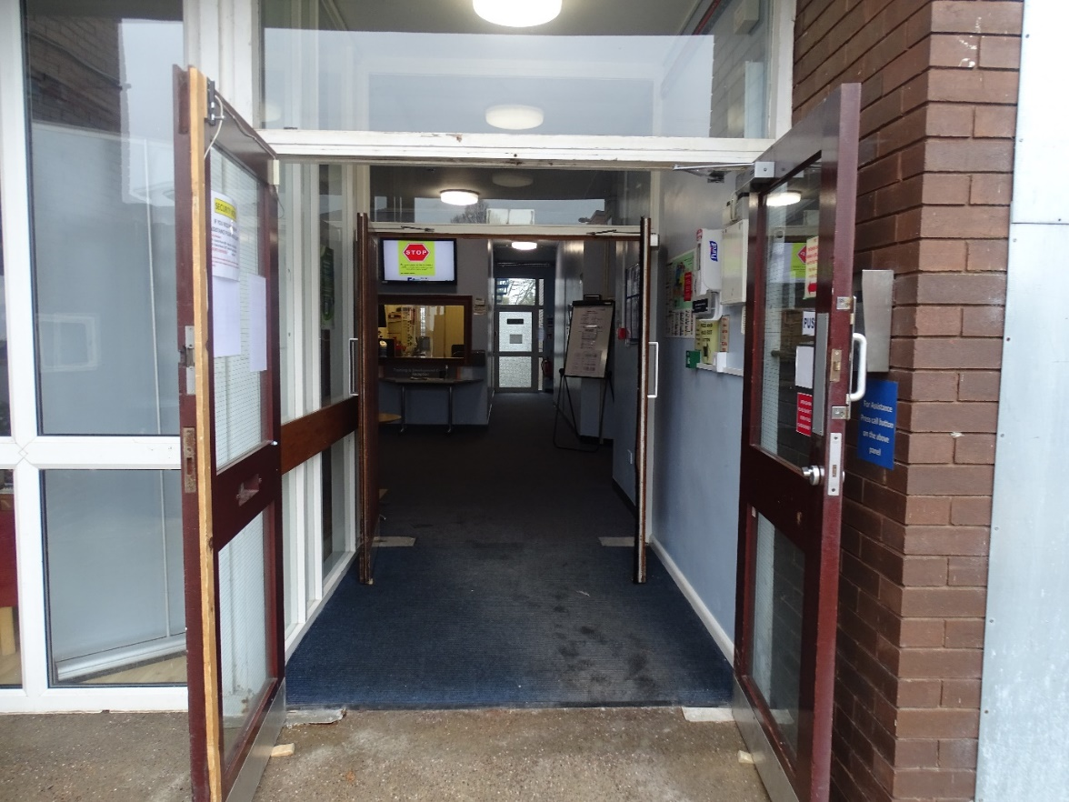

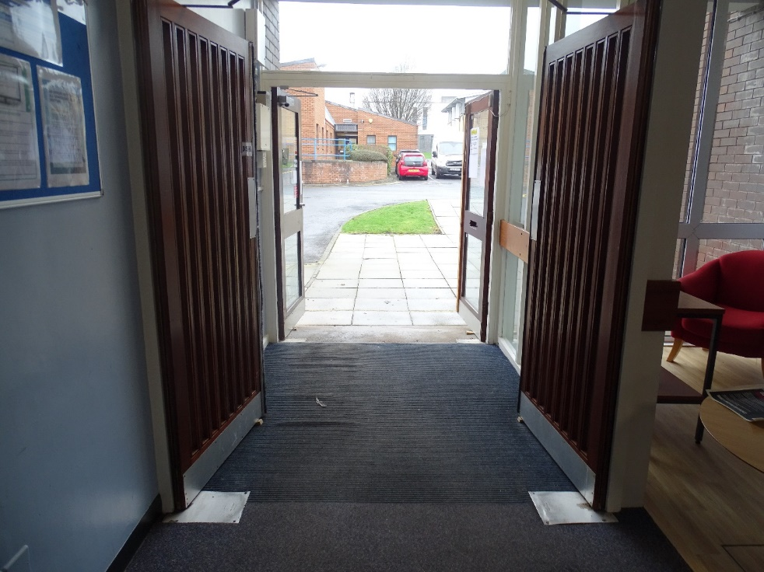

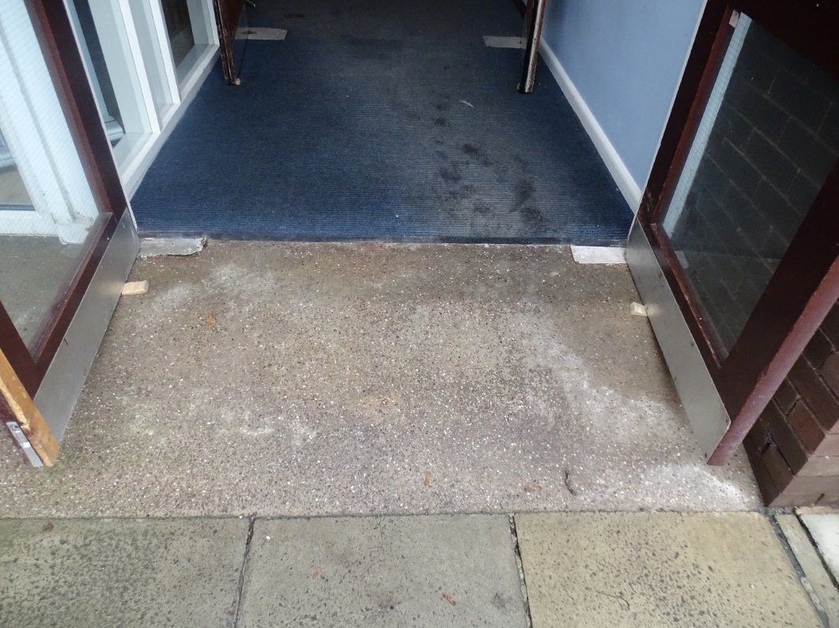

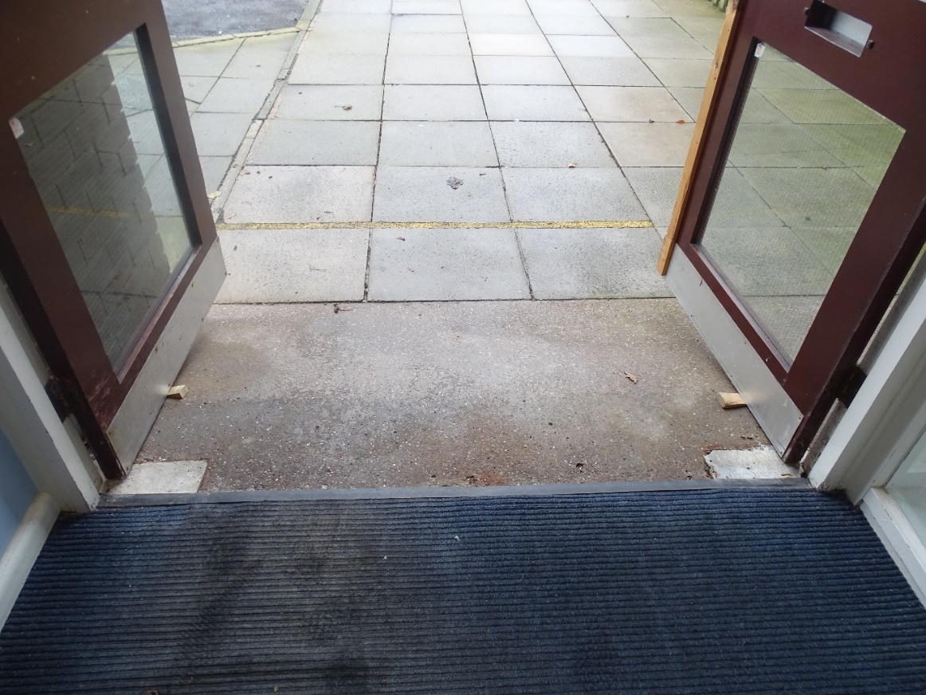

Stairs
- There are 18 steps.
- The height of each step is = 7.5 inches / 19.05cm.
- The width of each step is = 46.5 inches / 117cm.

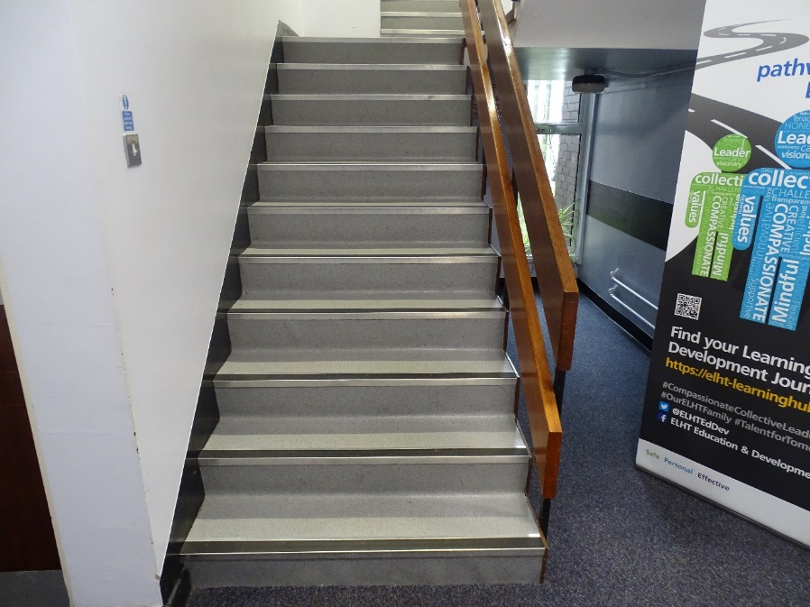

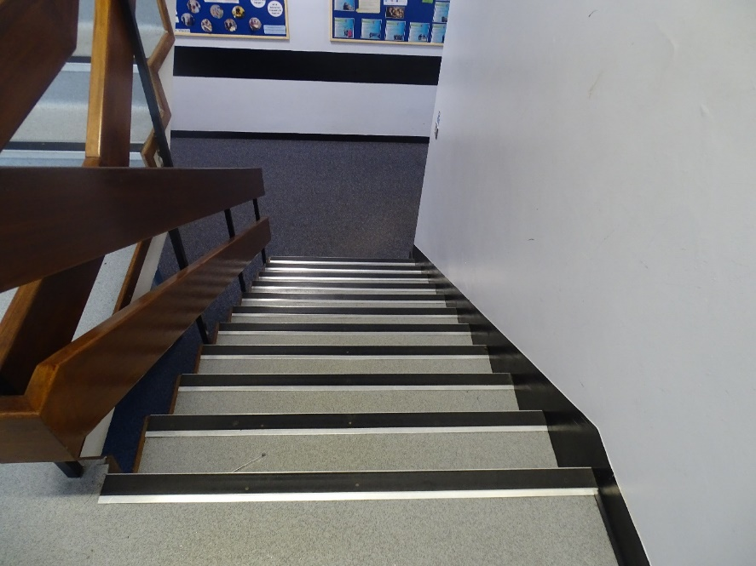

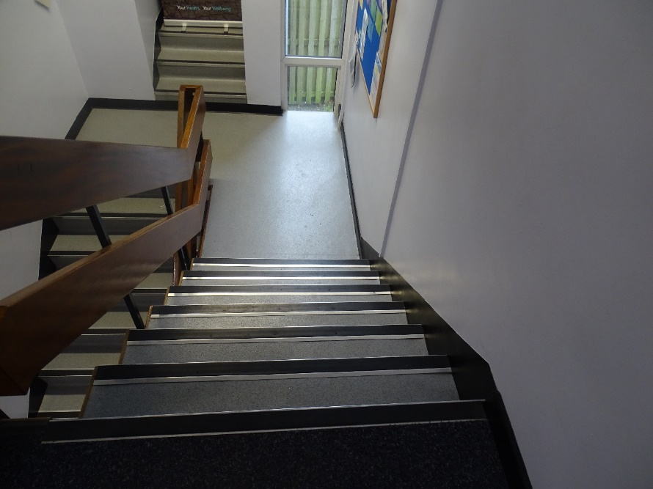

Gents Toilets
- The Gents toilets are located on the ground floor of the Training and Development Centre.
- There are 2 cubicles available in the Gents toilets.
- The height of the entrance door to the toilets is = 77 inches / 195.58cm.
- The width of the entrance door to the toilets is = 32 inches / 81.28cm.
- When entering the toilet, push the door.
- When exiting the toilet, pull the door.
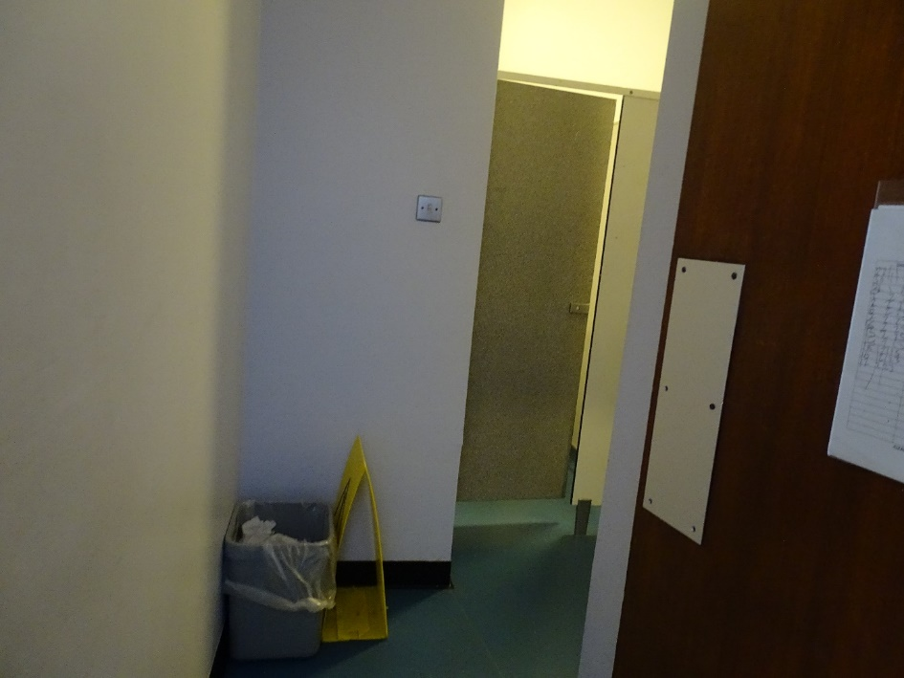

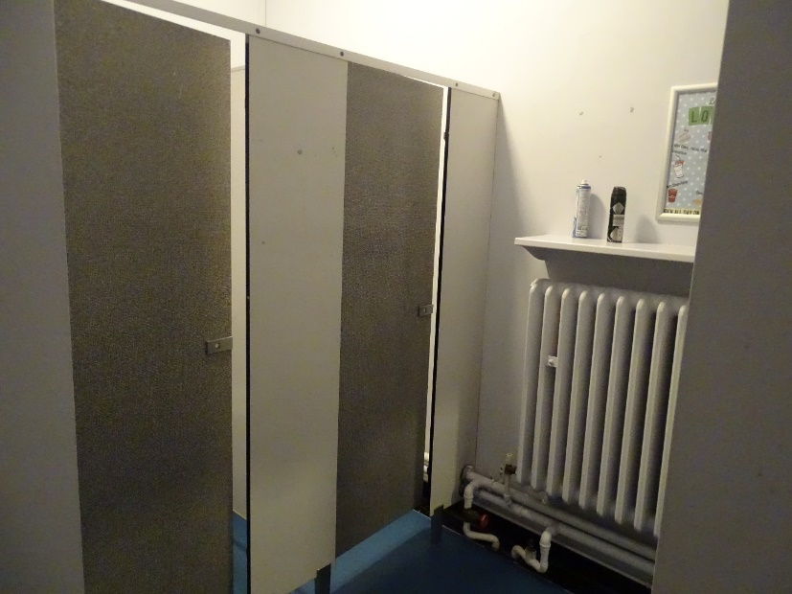

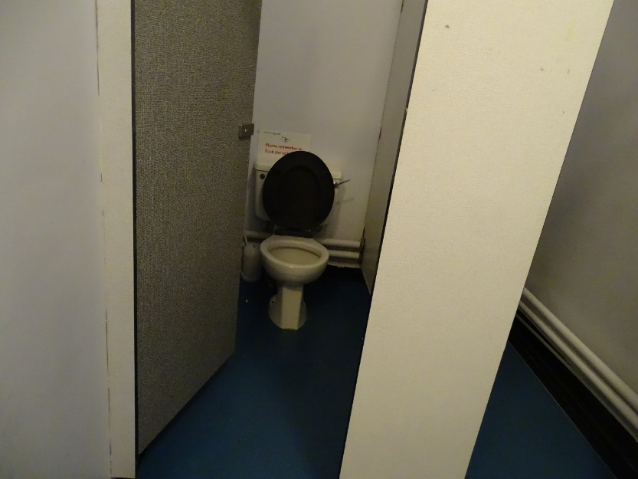

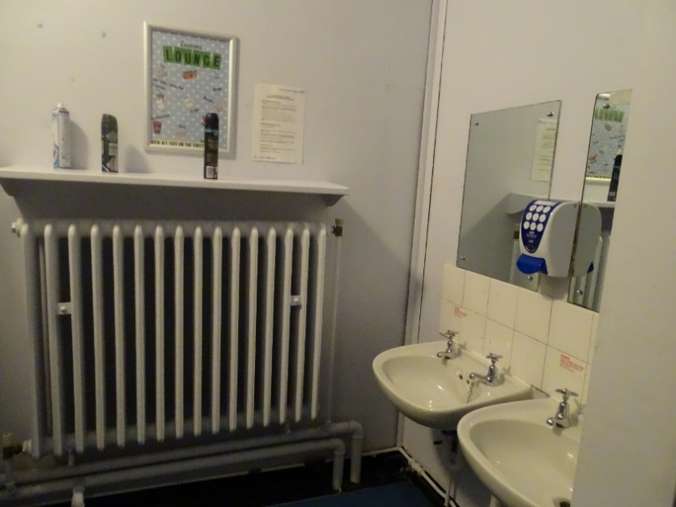

Ladies Toilets
- The Ladies toilets are located on the ground floor of the Training and Development Centre.
- There are 6 cubicles available in the Ladies toilets.
- The height of the entrance door to the toilets is = 77 inches / 195.58cm
- The width of the entrance door to the toilets is = 32 inches / 81.28cm
- When entering the toilets, push the first door and then the second.
- When exiting the toilets, pull the first door and then the second.

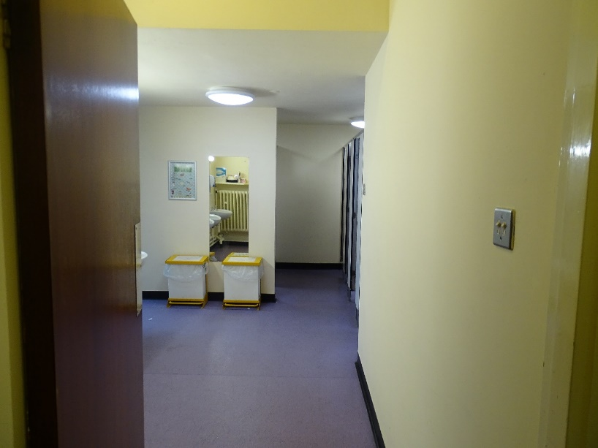

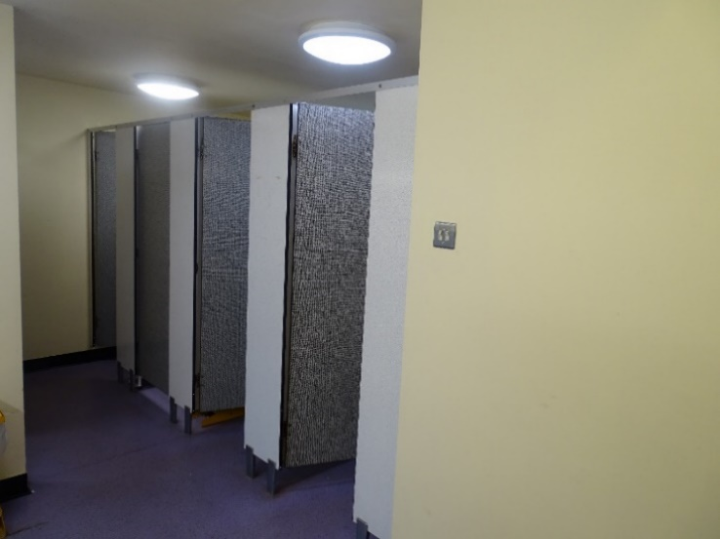

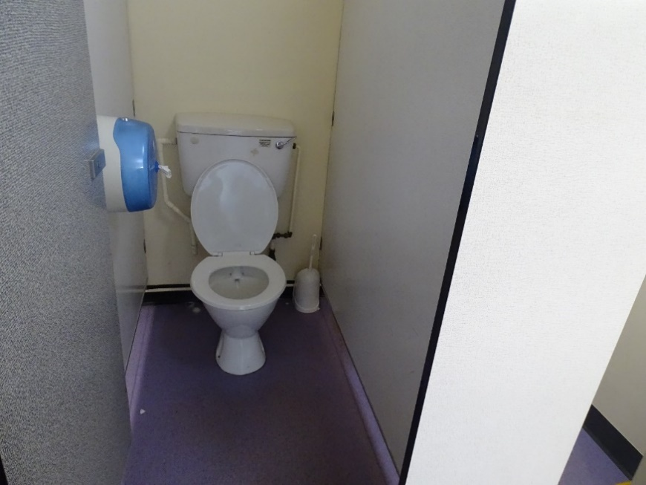

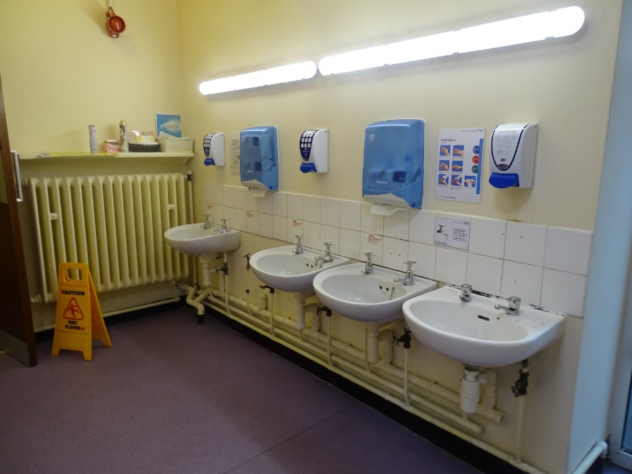

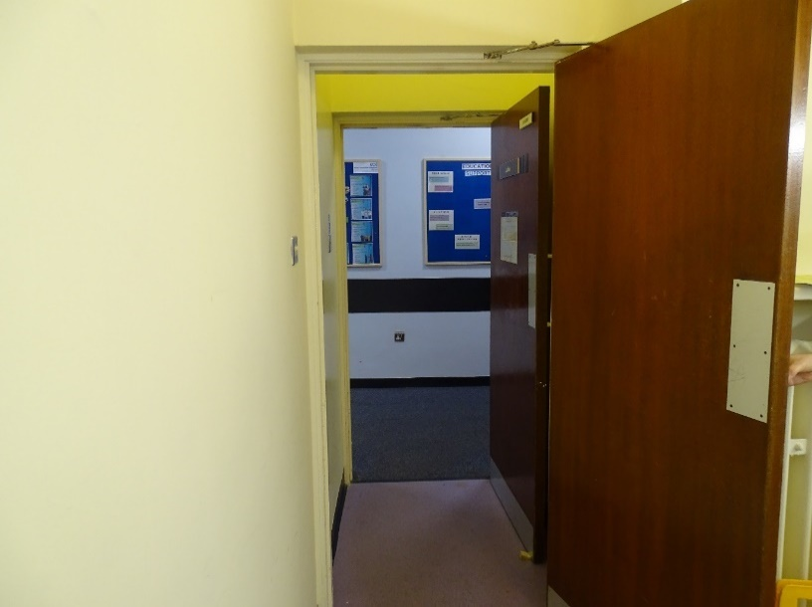

Tea and Coffee Facilities
We have tea and coffee making facilities on both the ground and first floor of the Training and Development Centre.

Ground Floor -

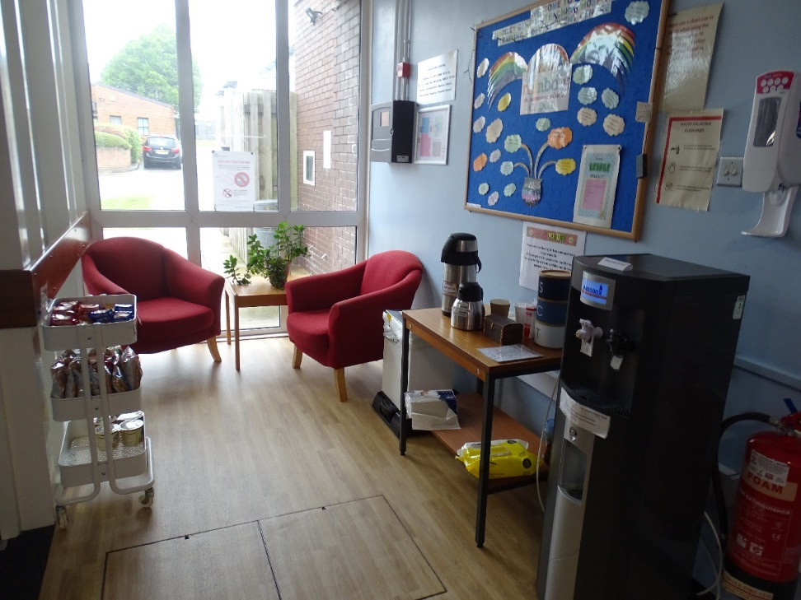

First Floor -

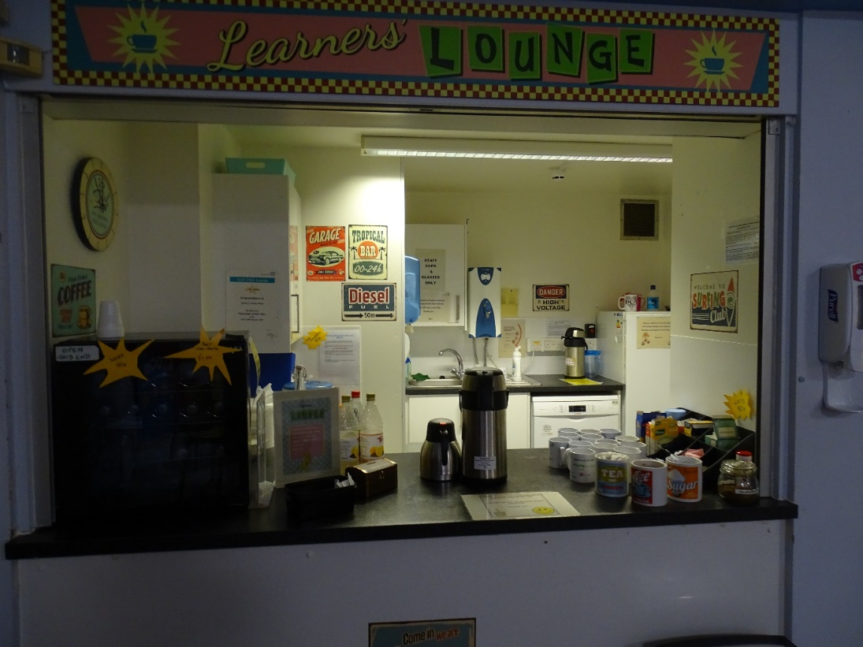

Car Parking
Outside the Training and Development Centre, we have two disabled parking spaces for staff / visitors to park in.

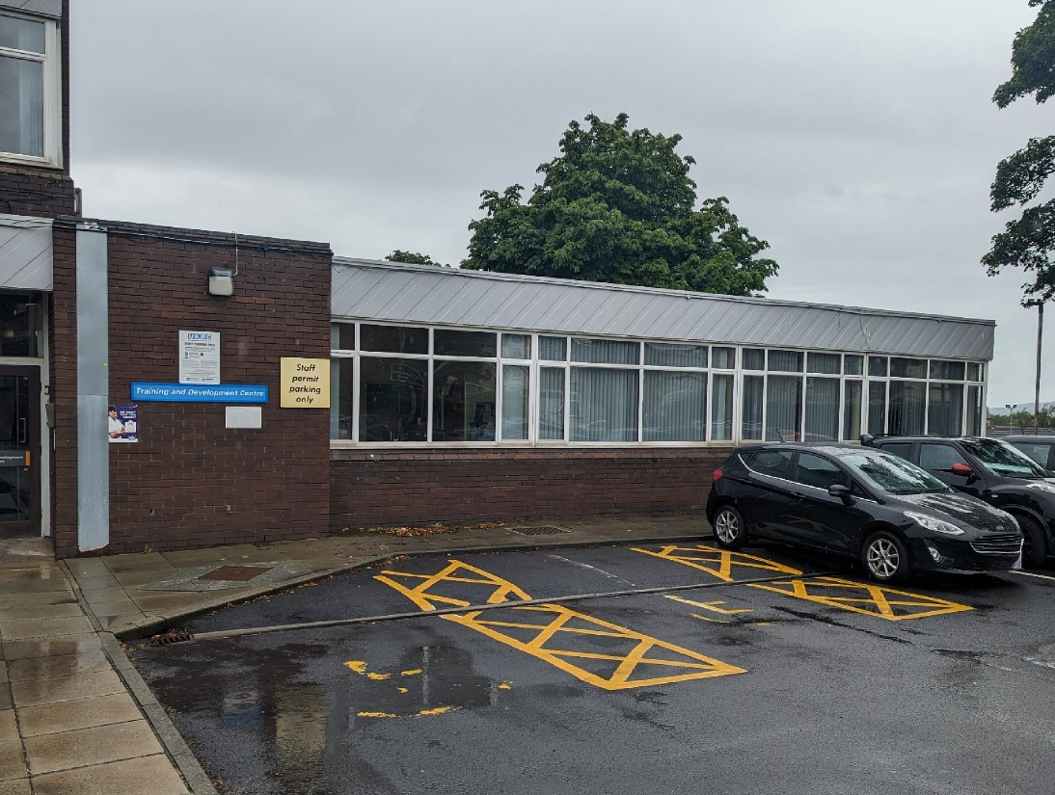

There is a large gravel car park to the left of the centre for staff.
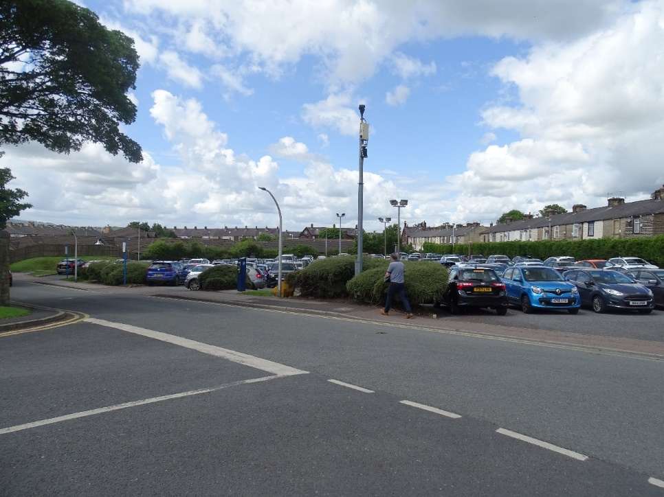

Next to the Training and Development Centre is the McKenzie Library. There are no disabled car park spaces outside the library, but there are 6 disabled spaces next to the building for staff / visitors to park in.

