



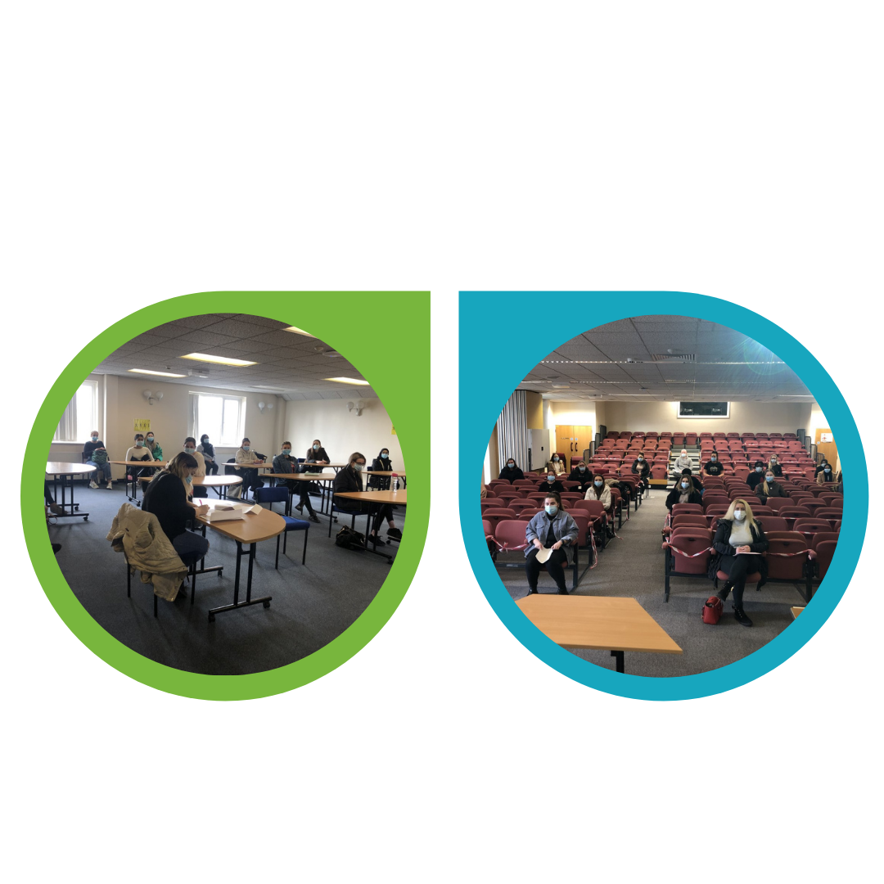

**Research, Development and Innovation**

Room 1.86 Park View Offices

Royal Blackburn Hospital

Blackburn, BB2 3HH

Tel: 01254 732756

Email: research@elht.nhs.uk

Web: [www.elht.nhs.uk/research](http://www.elht.nhs.uk/research)

Twitter: @ELHTresearch

**Research for early miscarriage**

### The ELHT DERI Women and Children’s Health Research Team entered their first patient into [the CERM trial](https://warwick.ac.uk/fac/sci/med/research/ctu/trials/cerm). The research, sponsored by University Hospitals Coventry and Warwickshire NHS Trust, and led at ELHT by Miss Fiona Clarke, is a randomised trial comparing the antibiotic doxycycline with placebo. The study aims to see whether antibiotic treatment reduces miscarriage and can increase the number births in women who have experienced two or more early miscarriages. Additionally, the research will look at the microbiome in the reproductive tract to see how this is affected by antibiotic use. The trial will take place in NHS hospitals in the United Kingdom and will involve over 3,000 women who have recurrent miscarriage. Two East Lancashire women have volunteered to take part in the research and further patients are awaiting screening for the study.

Senior Research Midwife, Bev Hammond said:

"We know how devastating miscarriage is for women and their families, and hope that by undertaking this study at ELHT we can offer further support for those affected by recurrent miscarriage. We hope the results will provide some clarity on the reasons why it happens. We would like to thank the Family Care Division, as always, for supporting us in delivering this important study."

**Increase in cancer trial activity**

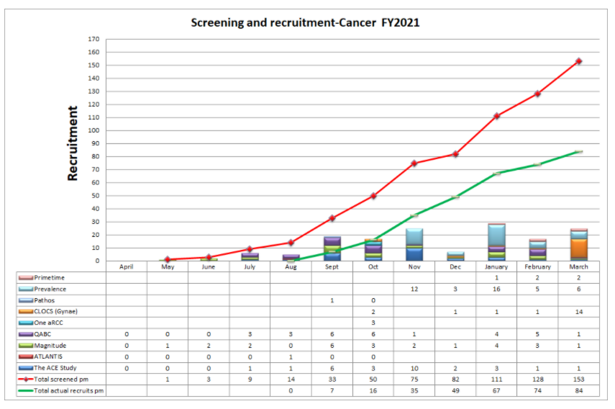

In a difficult year, the ELHT Cancer Research Team has achieved a 25% increase in research activity, enabling 83 East Lancashire patients to take part in cancer studies. And for the year ahead, the team are already looking at the

Continued overleaf…

**Welcome our new Student Nurses**

On the 18th and 19th of March, we hosted Corporate Inductions for 164 Student Nurses,  over 2 days, divided into 6 groups. Firstly, they undertook a welcome meeting with the PEF team, followed by a 'Vision and Values' session with the Induction Team.

The Practice Education Facilitator Team addressed:

* Car parking
* Uniform policy
* Sickness and absence
* Assessment document
* ID badges

The Induction team then delivered ELHT's 'Vision and Values' including Fire Safety session.

With thanks to:

* Reception staff for organising rooms, keys, administrative duties and directing our Student Nurses
* Demi Houghton and Momeena Butt for meeting and greeting, signing in and directing our Student Nurses on the day
* Learning Management Systems staff for setting up Learning Hub accounts for each student
* Jack and Stephen for maintaining high standards of cleanliness throughout all areas

**Education**

Learning Centre, RBTH

Training & Development Centre, BGTH

Email: deriwebsite@elht.nhs.uk

Web: https://deri.elht.nhs.uk/

Twitter: @ELHT_DERI

**Education and research bulletin, April 2021**

**ELHT research news**

**Work Based Education**

**HCA fast track recruitment programme**

ELHT have partnered with Nelson & Colne College and Lancashire Adult Learners to pilot a fast-track recruitment programme to employ and train 100 new Healthcare Assistants at the Trust. This programme has been designed to support our local community who may been affected by the Covid 19 pandemic, offering them an opportunity to retrain and commence a nursing pathway at ELHT.

The new Healthcare Assistants will benefit from a bespoke one week training programme facilitated by the Work Based Education Team.

The programme begins with Trust Induction, individuals then complete section 1 of the Care Certificate Award through dedicated support via Microsoft Teams sessions, led by Jenny Higson & Nelson & Colne College, they also attend a face to face practical training day to prepare them for working on our wards to provide safe, personal & effective care.

The programme has been a huge team effort including significant contribution from Recruitment, Human Resources, Induction Team, CAST team, sewing room, general office and the on-going support provided by our amazing ward staff.

Early evaluations show that the new recruits are feeling prepared and knowledgeable for commencement in their new roles. Feedback comments included ‘ I have really enjoyed the practical sessions, staff demonstrated and explained step by step procedures this has all contributed to an excellent introduction to the career and l now feel confident to start my new role”

**Kickstart scheme**

ELHT have partnered with the Department of Work and Pensions and Lancashire Adult Learners to launch our first Kickstart placements. The placements are fully funded by the government to provide 6 month paid opportunities for young people.

The DWP have recruited young people who are currently attending virtual lessons with LAL to build confidence, employability skills and health & social care knowledge prior to the placements.

Mims Davies, Minister for Employment attended a lesson with the young people where they joined in a thought provoking session exploring ELHT’s Vision & Values. It was fantastic to hear how the group were benefitting from the learning and Mims was impressed with the partnership working to provide employment opportunities to local young people.

The young people will be interviewed for the placements in April 2020 and we look forward to welcoming them to the Trust.

Feasibility of new studies which will include both commercial and academic research studies.

Rachel Bolton, Senior Cancer Research Nurse said:

“The team has worked exceptionally hard in such a difficult year to deliver this activity for our patients.”

**Anniversary marks a year of COVID-19 research**

A year of COVID-19 research at ELHT was marked by the ELHT DERI Research Delivery Team. On 18th March 2020, the first East Lancashire patient was entered into the ISARIC4C study, and in the last 12 months, over 6000 patients have entered COVID-19 research studies.

Wendy Goddard, Senior Research Nurse and Team Leader for the COVID-19 and Multidisciplinary Research teams reflected on the past year: “It's an incredible achievement. I would like to thank you for the support and dedication you have given to this team during that time. You have all been amazing and I'm proud to have been part of what has been a very challenging experience. Thank you all for everything you have done to gather such important and life changing information.

Dr Srikanth Chukkambotla, ELHT Consultant in Anaesthesia & Critical Care and Director for Research & Innovation agreed:

“This is an incredible achievement given the crisis times. I think we all should be proud of working together as a team to contribute to science and to defeat this pandemic. I thank you all for showing the flexibility, adopting, leading and most importantly the commitment.”

**Patient Research Experience Survey launches**

The National Institute for Health Research Clinical Research Network Greater Manchester (NIHR CRNGM) has launched this year’s Patient Research Experience Survey (PRES). Patients who’ve taken part in NIHR-supported research will be invited to complete a short questionnaire online. The responses will be shared with local research delivery teams and the NIHR to help improve research. This year the survey will invite patients to consider registering with [**Research for the Future**](http://www.researchforthefuture.org) in order to find out more about taking part in health and social care research. The survey can be [**accessed online by following this link**](https://docs.google.com/forms/d/1BjPSliNtWOqGUcZd43CeCfEM55yxhiZ9XWaVbkq7B50/viewform?edit_requested=true).

**Expanded service for Research for the Future** 

Research for the Future is a NIHR-supported initiative that helps people find out about and take part in health and care research in Greater Manchester, Cheshire and East Lancashire. Recently, the service has been expanded to enable people to register their interest in all types of health and care research. Everyone aged over 18 years is welcome to register. The service also helps researchers find suitable volunteers for a range of research opportunities.

To find out more, visit [**www.researchforthefuture.org**](http://www.researchforthefuture.org) or text **RESEARCH** and **YOUR NAME** to **81400** and an advisor will call you back.

**Network news**

**A Mindful Minute**

A year ago, Janet Gray and Connor Watson-Reid worked collaboratively on a series of Mindfulness Minute videos to bring more awareness of Mindfulness and meditation within ELHT. With the pressures and stress caused by the Coronavirus pandemic; offering mindfulness and the guided meditations have been a valuable resource to support our ELHT staff member’s health and wellbeing.

A year on from the beginning of this pandemic and after a tough winter, these videos remain relevant to us all. They are still being circulated throughout the trust which goes to show they are still sparking curiosity and interest.

If it is safe for you to do so, why not give them a go? You may be surprised how effective one minute can be in calming and tending to the body, mind and emotions.

“As an Assistant Digital Learning Developer, I took on the editing of these videos, and as well as great project experience, the videos also introduced me to mindfulness, which has helped to relax and be in the moment more ever since.”

To access the Minute Meditation Videos, click the below links to the Education YouTube Channel:

[**Benefits of practicing mindfulness**](https://www.youtube.com/watch?v=2WNpBrSNiBA)

[**Body scan**](https://www.youtube.com/watch?v=EMiQopuVBtU)

[**Grounding**](https://www.youtube.com/watch?v=69H8PJUNC1M)

[**Hand on the heart**](https://www.youtube.com/watch?v=A44mWPjkU5o)

[**Mindful brew**](https://www.youtube.com/watch?v=fDhTPd9O_pw)

[**Noticing the pleasant**](https://www.youtube.com/watch?v=ywVh5oDZ2dk)

[**Soothing self-compassion break**](https://www.youtube.com/watch?v=f2nB3IKgHBg)

[**Thoughts meditation**](https://www.youtube.com/watch?v=EbNyv-XI1n4)

[**What is mindfulness?**](https://www.youtube.com/watch?v=z0TT34MWFdQ)

**‘Thank you’ campaign to mark 1 million UK COVID-19 participants**



The NIHR Greater Manchester Clinical Research Network (CRNGM) joined organisations across the UK to [**mark the entry of 1 million participants into COVID-19 research**](https://local.nihr.ac.uk/news/greater-manchester-people-help-uk-covid-19-research-pass-one-million-participants/27253), and to say ‘thank you’ to NHS staff members and over 30,000

volunteers from across Greater Manchester, Cheshire and East Lancashire who took part in over 40 nationally-prioritised COVID-19 studies.

Important results from the research include:

* **RECOVERY** trial showed that tocilizumab, an anti-inflammatory rheumatoid arthritis treatment, [**reduces the risk of death for hospitalised patients**](https://www.recoverytrial.net/files/recovery-press-release-tocilizumab_final.pdf) with severe COVID-19.
* **RECOVERY** and **REMAP-CAP** trials found [**no evidence of benefit from convalescent plasma**](https://nihr.us2.list-manage.com/track/click?u=274f30efd509212096c3a2496&id=730ec8112b&e=f95ed0da9b) as a treatment for hospitalised COVID-19 patients. This arm has now closed.
* **REMAP-CAP** found tocilizumab and sarilumab - both types of immune modulators - [**have a significant impact on patient survival**](https://nihr.us2.list-manage.com/track/click?u=274f30efd509212096c3a2496&id=4c60afff67&e=f95ed0da9b)**.**
* **SIREN** study found that past COVID-19 infection provides [**some immunity for at least five months**](https://nihr.us2.list-manage.com/track/click?u=274f30efd509212096c3a2496&id=72828aa096&e=f95ed0da9b), but people may still carry and transmit the virus.
* **PRINCIPLE** trial found that the commonly used antibiotics, azithromycin and doxycycline, [**do not reduce recovery time**](https://nihr.us2.list-manage.com/track/click?u=274f30efd509212096c3a2496&id=771652c602&e=f95ed0da9b) for patients. These arms have now closed.

Professor Chris Whitty, Chief Medical Officer for England and co-lead for the National Institute for Health Research (NIHR), said: “Reaching 1 million participants in COVID-19 research shows the impressive selflessness of people across the UK who have volunteered to take part. This research has led to vaccines, better treatments and improved care.  A huge thank you to everyone who has taken part in, led, or enabled the research.”

**The future of UK clinical research delivery**

A new vision for the future of clinical research has been published. ***‘Saving and improving lives: the future of clinical research delivery’***, developed by the UK government and devolved administrations is underpinned by 5 themes:

* Clinical research embedded in the NHS
* Patient-centred research
* Streamlined, efficient and innovative research
* Research enabled by digital tools
* A sustainable and supported research workforce

To find out more, visit [**gov.uk**](https://www.gov.uk/government/news/uk-government-sets-out-bold-vision-for-the-future-of-clinical-research-delivery).

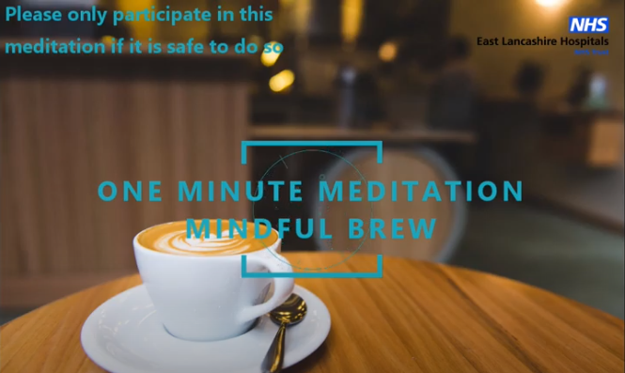

**National news**

**Welcome to the Safer Handling Learning Portal**

This Dashboard is to support and assist you in Safer Handling. Each Tile represents different aspects of learning. We recognise that each role requires different elements of practice.

To access, click [**here**](https://elht-learninghub.co.uk/totara/dashboard/index.php?id=178)

**Recognition and Response – an initiative by Paul McCaffrey and Jenna Kenny**

Our clinical activity support team has designed a brand new training event.

The focus is on the management of deteriorating patients and cardiac arrest based on real-life scenarios. It looks at management strategies, technical and non-technical skills, communication, teamwork, and human factors.

This course was created in response to identifying themes in clinical incidents.

The incidents are then recreated under simulation then reflected upon as a group to consider the learning points.

We have run three sessions so far and had lots of positive feedback; attendees have said that it has given them more confidence in managing deteriorating patients.

Published to Fab NHS stuff – [**read more**](https://fabnhsstuff.net/fab-stuff/recognition-and-response-simulation-training)

**New video celebrates the work of research nurses and midwives**

The NIHR CRN Nursing and Midwifery Office has announced it will be creating a new video to celebrate the work of research nurses across the UK. The video will be launched to mark International Nurses Day in May. The creators will be writing to research nurse leaders and workforce leads to request photos of individuals or small groups of research staff in their uniforms undertaking the various aspects of their roles.

**Changes to UK study amendment process**

Changes have been made to the UK study amendment process and ***a new version of the HRA amendment tool is now in use (v1.5)***. The changes apply to CTIMP studies and are as follows:

* The addition of a new NHS/HSC site, or a change of PI at an NHS/HSC site, will now be classified as a Non-Substantial Amendment. This was previously considered a Substantial Amendment.
* The amendment tool can now be used to notify MHRA of substantial amendments

The HRA has produced a short video, explaining the changes, which available via the [**HRA Learning Management System**](https://hra.premierit.co.uk/login).

**The ENGAGE study**

The ENGAGE study has been published in the journal [**Breast Cancer Research and Treatment**](https://pubmed.ncbi.nlm.nih.gov/33733302/). The research investigated decision-making among women considering the use of tamoxifen for the prevention of breast cancer.  Past and present members of the ELHT DERI Cancer Research Team were among those acknowledged for their contribution by the authors.

**Clarity research findings published**

An urgent public health study, supported at ELHT by Dr Joe Collum, Research Nurse Farzana Masters and 100 East Lancashire patients, has shown that infliximab, a commonly prescribed treatment for inflammatory bowel disease (IBD) blunts the immune system to COVID-19 infection, potentially increasing susceptibility to recurrent COVID-19. The results of the [**CLARITY study, published in GUT**](https://gut.bmj.com/content/early/2021/03/19/gutjnl-2021-324388), showed that fewer than half of people with IBD who were treated with infliximab had detectable antibodies after SARS-CoV-2 infection. The study was led by gastroenterologists at the Royal Devon and Exeter NHS Foundation Trust and the University of Exeter Medical School and studied 6,935 patients with Crohn’s disease and ulcerative colitis from 92 UK hospitals between September and December 2020. The authors advise that patients continue to take their medication as overall Covid-19 risk remains very low.

**Females in hospital with SARS-Cov-2 infection**

A [**paper authored by academics from the ISARIC4C Consortium, UKOSS and CO-CIN**](https://www.gov.uk/government/publications/ukossisaricco-cin-females-in-hospital-with-sars-cov-2-infection-the-association-with-pregnancy-and-pregnancy-outcomes-25-march-2021) has been presented to the government SAGE committee. The pre-print publication highlights an excess of hospitalisations for women of reproductive age compared to men and summarises the data collected to date on pregnancy outcomes. Bev Hammond, Senior Research Midwife thanked everyone for their support and work involved in the study: “The Reproductive Health team have been instrumental in identifying these women, reporting and collecting/inputting data for both of these highly important Urgent Public Health studies, and liaising with the COVID Research Team to ensure they were captured appropriately. These are important findings, and the data continues to be needed to improve outcomes.”

View [**articles published by ELHT staff**](http://www.ehub.elht.nhs.uk/view-latest-staff-publications) and the [**ELHT Library Catalogue**](http://eastlancshealth.nhslibraries.com/Scripts/Hapi.dll/search2?searchterm=*&Fields=%40&Media=SP&Bool=AND). For a complete, searchable, selection of summaries of NIHR research visit the [**NIHR evidence website**](https://evidence.nihr.ac.uk/).

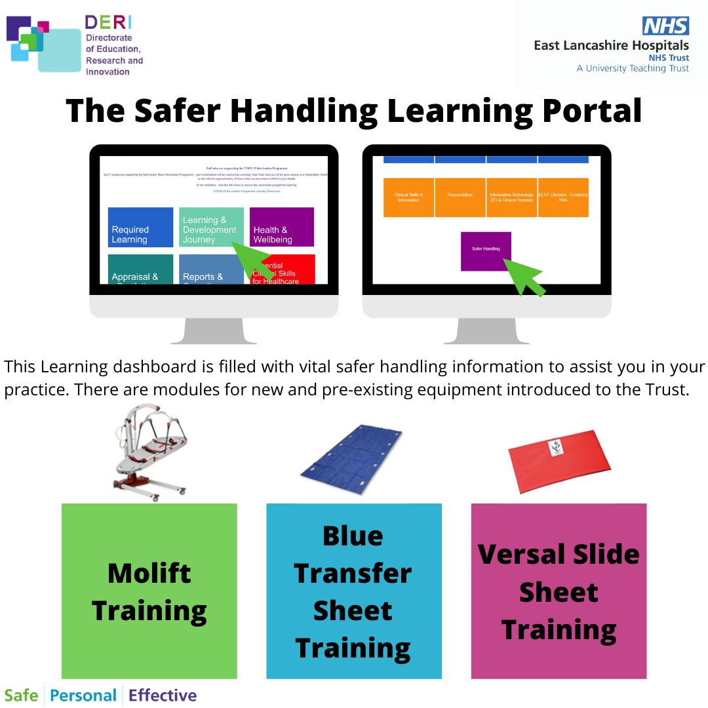

**Publications**

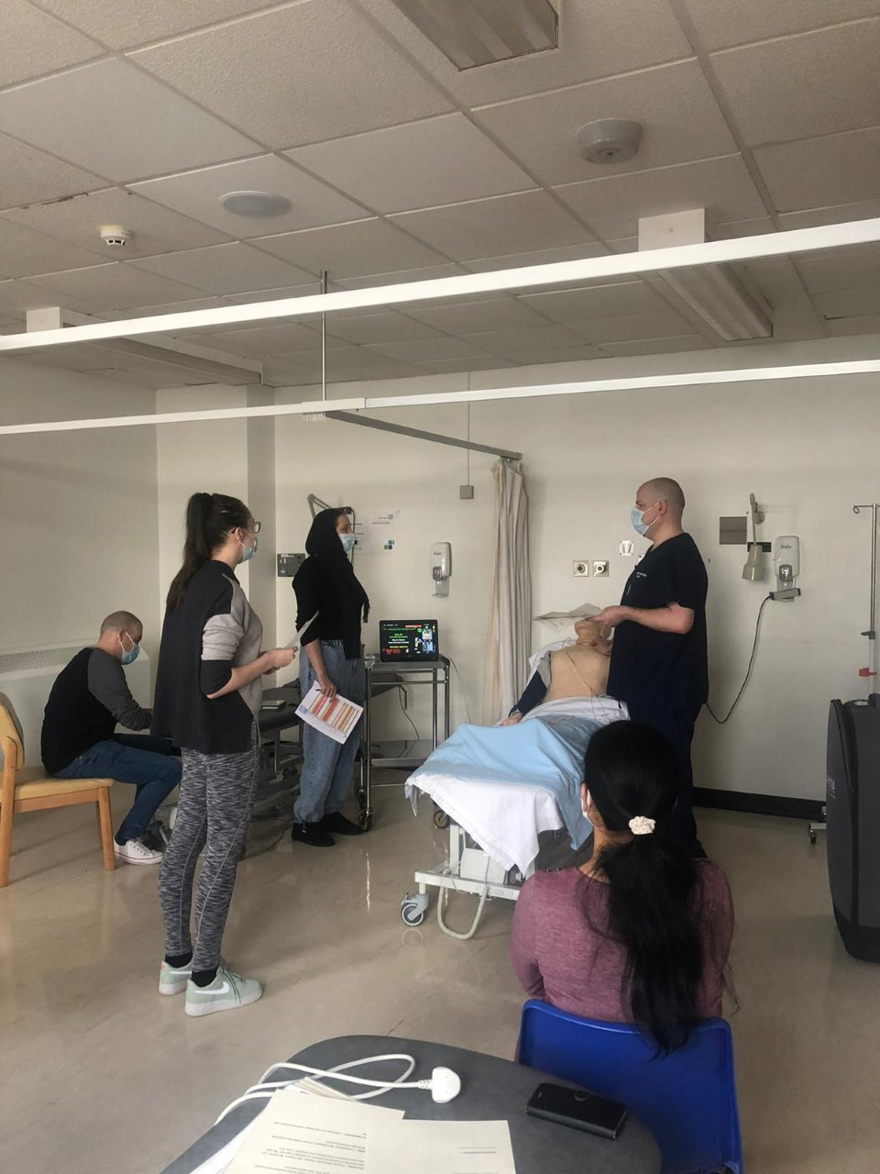

**Professional development**

**Network news**

**Nursing and midwifery research careers advisory service**

The National Institute for Health Research (NIHR) [**Nursing and Midwifery Incubator**](https://www.arc-wx.nihr.ac.uk/nihr-incubator/), in partnership with the [**NIHR Research Design Service**](https://www.nihr.ac.uk/explore-nihr/support/research-design-service.htm) (RDS), are piloting a virtual careers advisory service to help aspiring clinical academic nurses and midwives to start and advance their research careers. The service is being piloted in the North West, East Midlands and South East. Enquiries to the service will be reviewed by an experienced RDS adviser. For more information on the service and to submit an enquiry, visit the [**Nursing and Midwifery Research Careers Advisory Service website**](https://www.arc-wx.nihr.ac.uk/nihr-incubator/clinical-academic-career-advisory-service/).

**NIHR Academy mentorship programme**

The [**NIHR Academy**](https://www.nihr.ac.uk/explore-nihr/support/academy.htm) was established in October 2018 to develop a highly-skilled academic research workforce which is capable of advancing the best research. A new mentorship programme will now be offered to NIHR Academy members for all professions and disciplines at the post-doctoral level. More information about the programme can be found on the [**NIHR Academy mentoring webpage**](https://www.nihr.ac.uk/explore-nihr/academy-programmes/nihr-leaders-support-and-development-programme?utm_source=gmail&utm_medium=email&utm_campaign=academy-mentoring-programme%3E). People can register their interest in joining the programme as a [**mentor**](https://docs.google.com/forms/d/1Zx2ztwdwwI_G04yfd-CvhzSpAN-7oET0vwwT10iHqvE/viewform?edit_requested=true) or [**mentee**](https://docs.google.com/forms/d/1XqiMjOy3c02zwNw_iYD3q2IrXNJm2_-tpfIb6rE5384/viewform?edit_requested=true). The closing date is 12th April 2021.

**Courses**

**Improving healthcare through clinical research**

Developed by the University of Leeds and the NIHR, this free online course, shows how medical treatments are discovered, tested and evaluated to improve healthcare.

**Date:**  Available now

**Location:**  Online, 4 hours per week for 4 weeks

**Cost:** Free

[**Further information**](https://www.futurelearn.com/courses/clinical-research):

**Reflect and connect symposium: Research before, during and after COVID-19**  
**Date:**  17-21st May 2021

**Location:**  Online  
**Cost:**  £100 (+VAT)

[**Further information**](https://rdforum.nhs.uk/reflect-connect/):

**Resources**

**Biomarker-guided trial designs (BiGTeD)**

Personalized medicine is a growing area of research which aims to tailor the treatment given to a patient according to one, or more, personal characteristics. These characteristics can be demographic, such as age or gender, or biological, such as a genetic or other biomarker. A number of clinical trial designs have been proposed for testing a biomarker’s clinical utility. Based on a comprehensive review of biomarker-guided trial designs, the [**BiGTeD resource**](http://www.bigted.org) presents an overview of adaptive and non-adaptive biomarker trial designs. Each trial design is represented graphically together with an overview of its key characteristics, methodology, and its pros and cons.

**Virtual Medicine Work Experience**

​This programme is designed for year 12 students applying to medical school. The programme is expected to run for approximately 10 weeks every Wednesday 8.30am-4.30pm beginning on the 28th April 2021. There are a limited number of places and all applications that meet ELHT’s criteria will be allocated on a first come, first served basis. The work experience is online and will be hosted via Microsoft Teams.  
  
​Aims:  
1. To provide insight into a career in medicine  
2. To support the application process  
3. To appreciate the patient journey  
4. To raise awareness of the importance of the multidisciplinary team  
5. To discuss qualities that make a good Doctor  
6. To increase awareness of the General Medical Council’s (GMC) role and expectations  
7. To introduce the concept of situational judgement

[**APPLY HERE**](https://deri.elht.nhs.uk/medicine-work-experience-application-form.html)

**Directorate of Education, Research and Innovation**

Did you know…we can help support you in further education and training, finding evidence for general interest and personal development, research or assignment, evidence-based practice for patient care, service management, up-to-date protocols and guidelines. [For more information](https://education.elht.nhs.uk)



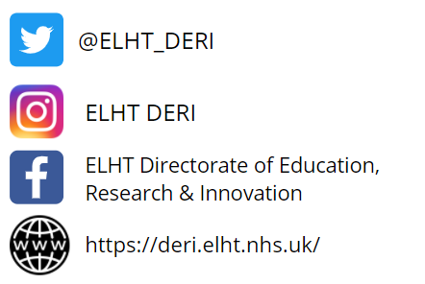

**If you have an article you’d like to include in a future edition of this bulletin, please contact:**

**Education stories: deriwebsite@elht.nhs.uk**

**Research stories: hazel.aston@elht.nhs.uk**

**Library Service Update**

**Network news**

Covid hit and despite running with a skeleton team (staff redeployed, remote working) we managed to run an effective day to day service.

We kept the Blackburn site open and offered a full service. The numbers of PC’s and study areas were reduced and there were lots of moving of tables and chairs to allow for social distancing. Our Library I.T Suite became Command Room for the HR Team.



**New Current Awareness Service**



The library has changed the way it is delivering current awareness. Patrick our Clinical Librarian has worked to create something convenient and interactive that is easily accessible of a mobile device.

Our new bulletins are online and our collections can be followed on the ReadQXMD App. We have integrated our resources with full text links to our holdings giving instant access.

In order to shape the content Patrick has worked with health professionals within various departments and this has also led to increases in searches and training.

We were very pleased to be awarded the LIHNN Service Development Gold Award for service improvement for this. It was great to be recognised in a strong field of submissions during this extraordinary year.

**Clinical Guidelines Project**

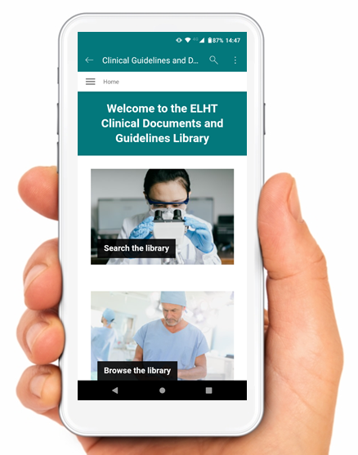

The clinical librarian has been seconded 2 days a week since October working on developing a new system to house the trusts Clinical guidelines and documents.

The initial pilot taking Nursing and Midwifery Care plans into the new system on Sharepoint has been successful and is near completion. Central funding was achieved with around £40,000 secured for two years for staffing.

It is a large project and it is expected to take a while to complete but the plan is to integrate documents in department by department.

**COVID-19 Activity**

**Equipment**

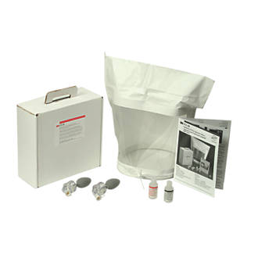

**Literrature Searches and Training**



**Heading**

Text

**Heading**

Our Burnley site library was unstaffed during this time, however library users still had access. All the risk assessments were in place and the space was rearranged to comply with social distancing so we still could offer 24/7 access to our users. We have now returned to staffing Burnley library Monday – Thursday.

The library took on the responsibility of loaning fit mask kits. We have 27 fit kits available for loan and we are using our library management system to keep track of usage and reservations.

A new journal club has been set up in the Midwifery department which had its first meeting this month. It went really well and it will become a monthly fixture.

Searches have been coming in and a lot of support has been given to people undertaking systematic reviews with around 3 from the neonatal intensive care unit alone.

The Clinical Librarian has been working closely with the Research department to work on outreach and we are hoping to develop joint teaching sessions for the future