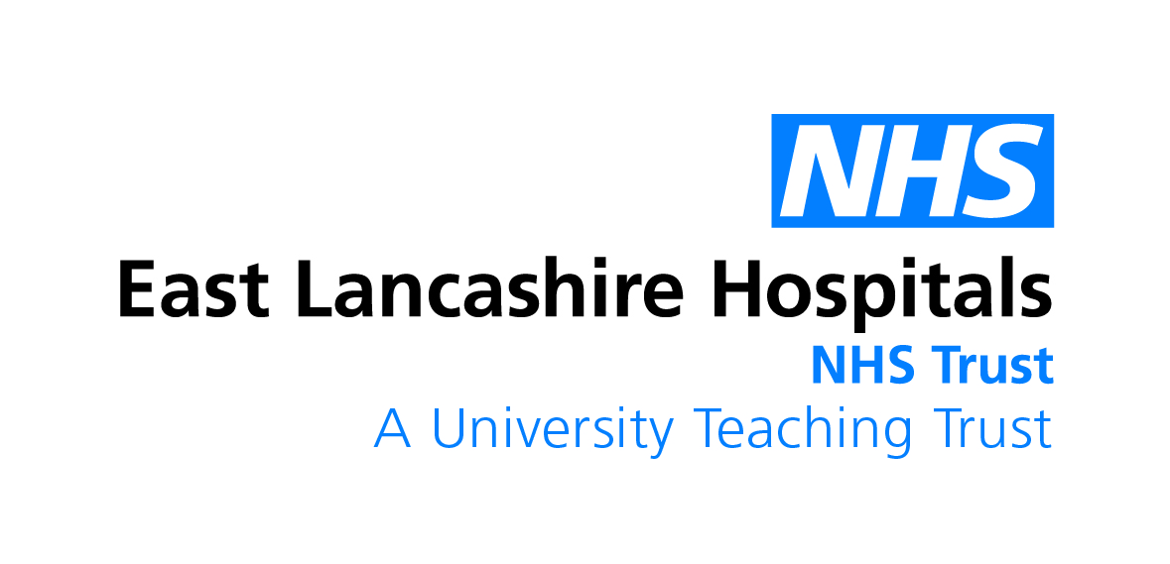
Dear ELHT Graduate
In the year 2020, the world has seen the catastrophic effects of a deadly pandemic. Thousands of students from many disciplines signed up to do paid clinical placements and many students saw their studies move to online. For students who have put in so much time and effort into their studies, this pause and change in your academic life will have no doubt been one of many challenges, worry and stress.

It is testament to your resilience, a testament to your dedication and resolve and the passion and commitment that you have displayed that makes us proud at ELHT to share your success at graduating in a year that history will never forget.

Class of 2020 yearbook

The yearbook was conceived and launched to recognise and celebrate the achievements of the class of 2020. We would like your stories and reflections in a year where you will be part of history, a success story that has come out of this year of pandemic.

Your Name:

Tell us a bit about yourself and what you studied:

What did you enjoy most about your course and any support you received from your tutors/supervisors/friends and colleagues?

COVID-19 crisis presented many challenges. How did you manage?

COVID-19 has forced the adoption of new ways of learning. Can you tell us about your experience and what advice you can give to potential students?

Who or what has been your inspiration?

What advice would you give others on reaching their potential or embarking on a career in health?

How did you look after your wellbeing?

Favourite quotes of all time:

Please attach a picture (optional) and we will include in our Online Yearbook

