Handbook for Clinical Fellows
East Lancashire Hospitals Trust

Compiled by Dr Chris Clark, Education Lead for Clinical fellows ,ELHT
Updated July 2022

Contents

 | Page number
Welcome | 3
Introduction | 3
Our objectives and values | 3
Before you get here | 4
What to expect in your first week | 4
Trust induction | 4
Specialty/ local induction | 4
Clinical Fellow induction | 4
Rolling induction programme | 5
Protected Time to Engage in Educational Activities | 5
Other teaching | 5
Supervision | 5
Supervised learning events | 6
Feedback | 6
Study Leave | 6
Keeping a Portfolio | 7
Certificate of Readiness to Enter Specialty Training (CREST) | 7
Mandatory Training | 7
Appraisal and revalidation | 7
Good Medical Practice | 8
Communication skills
Medical Indemnity | 8
Uniform/ Scrub Tops | 8
Leave | 9
Annual Leave | 9
Sick Leave | 9
Appendix A: Form for 1st supervisor meeting | 11
Appendix B: Form for interim supervisor meetings | 14
Appendix C: Form for End of Placement supervisor meeting | 15
Appendix D: Required DOPS for Clinical Fellows without UK Foundation | 16
Appendix E: Form for applying for Scrub tops | 17
Appendix F: Study leave guidance and form | 19
Appendix G: Accessing e-learning for 12 week rolling induction | 21
Appendix H: How to use OneDrive so you can share your SLEs and meeting records with your supervisor. | 24
Appendix H:Useful contacts | 27

Welcome
Firstly we would like to welcome you to East Lancashire Hospitals NHS Trust. We hope you find it a friendly and educational place to work.
This may be your first job in the UK and we appreciate that you may be feeling a bit lost at the moment and we have included a guide to the area written by one of our previous overseas doctors to help you settle in. If you need any help with getting settled please don’t hesitate to contact PGME@elht.nhs.uk and we will do our best to help.
Introduction
ELHT is a very busy trust with a large footprint and serves a very diverse population. The area covered includes some of the wealthiest areas in the country as well as some of the most deprived. This means that we see a very wide range of pathologies.
The Trust has 1041 beds: 709 at the Royal Blackburn Teaching Hospital, 240 at Burnley General Teaching Hospital, 22 at Clitheroe Community Hospital and 67 at Pendle Community Hospital. Last year we treated three quarters of a million patients.
On the ward you will work as part of a multidisciplinary team with many other professions which include: Nurses, Physiotherapists, Occupational Therapists, Dieticians, Advanced Clinical Practitioners, Physician Associates and Radiographers. (This list is not exhaustive.)If you are unfamiliar with any of the roles just ask the person in question and they will be happy to explain.
Our Objectives and Values
At ELHT our objectives are to:
- Put safety and quality at the heart of everything we do
- Invest in and develop our workforce
- Work with key stakeholders to develop effective partnerships
- Encourage innovation and pathway reform, and deliver best practice
Our values are:
- Put patients first
- Respect the individual
- Act with integrity
- Serve the community
- Promote positive change

Before You Get Here
Following your interview you will have received some paperwork to complete. Please ensure that you complete and return everything as requested.
You will need to name ELHT as your Designated Body for Revalidation. This can be done on the GMC Online here. You will need your GMC number to set up the account if you haven’t already done so.
The GMC offer an excellent resource called “Welcome to UK practice”. Information on booking these free workshops can be found here . We recommend that you take part in one of these workshops. They are currently being done online.
Please familiarise yourself with the GMC Guide to Good Medical Practice, which can be read online or downloaded here
What to Expect in Your First Week
Trust Induction
All new colleagues at ELHT undergo Trust induction on their first day with us. You will be told in advance the location, date and time that you are expected to attend. These are usually held on Mondays and Tuesdays.
Specialty/ Local Induction
If you join at the time when trainees rotate you will be invited to their specialty and local induction (avoiding the need for Trust induction), but all clinical fellows do not arrive at the same time. If you arrive at other times you still need to have these inductions, they will be arranged for you. A specialty induction tells you about how your department works and usually includes some hints and tips on best practice. A local induction is where you are shown round the places you will be working. This may include wards, outpatients and the admitting wards (Acute Medical Unit, Acute Surgical Unit etc.) where you will work when on emergency cover. Take the opportunity at both of these to ask questions including things like, “Where do I put my coat and bag where it will be safe?”, “Is there a fund for coffee etc.?”, “Who should I call in sick to if needed, and how?” or “When are the ward rounds?” All areas will have a rest room where coffee and tea can be made (there is usually a fund to contribute to) and there will be a fridge in which to store meals brought from home.
Clinical Fellow Welcome Meeting
The Education Lead for Clinical Fellows meets with all new clinical fellows within a month of them starting. This is an introduction to areas which are not covered in other parts of your induction. You will also find out how to access support. It is important that you attend this meeting or let us know if you are not able to. We will send a further invite if the first date is not convenient for you. This email will usually come to your personal email address.
Rolling Clinical Fellow Induction Programme
You will be invited to, and expected to attend, a 12 week induction programme aimed specifically at Overseas Doctors. If you are a British graduate or have done foundation training here you will be informed which sessions you need to attend.
Each week we will discuss areas covered by e-learning for Healthcare’s Foundation Module. You need to complete the appropriate modules before the session in order to be able to gain the benefit from the discussion. There will also be chance to have an open discussion about any issues or problems you are facing. It is a repeating programme designed to be joined at any time.
You will be sent the programme and should start attending the week that you start work with us, or the week after at the latest. This is compulsory and you should be released for the hour a week. The teaching takes place on Teams on a Tuesday afternoon 1530-1630. You will be sent a link to join.
Protected Time to Engage in Educational Activities
Your job plan gives you 2 hours a week of educational time. This can be used to attend local teaching, to attend a clinic, to use for QI work etc. The actual times at which you take this should be arranged with your supervisor and in conjunction with others on the ward on which you work.
Other Teaching
You should attend any teaching provided by your department/ division. You may not be allowed to attend every week as someone will need to cover the ward and medical trainees and other members of clinical staff also need to attend. You should however be able to attend in rotation with your colleagues.
e-learning
There are many sources of e-learning, these include the ELHT Learning Hub, BMJ learning, Doctors.net, e-learning for Healthcare etc. These are a good way of topping up knowledge.
Supervision
You will be allocated a senior doctor as your supervisor. You should arrange to meet them as soon as possible to discuss your role, your educational needs and any areas of concern. The form in appendix A should be used (fill in any personal details before the meeting to save time) and this should be uploaded to your appraisal portfolio and a copy kept in a file on OneDrive and shared with your supervisor. You should also keep a copy of any SLEs here. Instructions are in the appendices. The updating of your appraisal portfolio and uploading to the OneDrive is the responsibility of the JCF.
You should meet your supervisor regularly, not just in the course of day to day work, but also to have meetings every month. These should be documented using the form in Appendix B and uploaded to your appraisal portfolio and a copy uploaded to your shared file on OneDrive.
Supervised Learning Events (SLE)
An SLE is when you are observed in practice and given feedback on your performance. They are: mini clinical examinations (mini cex) where you are observed examining a system e.g. chest, case based discussions (Cbd) where you discuss a case and your plan with a senior and get formal feedback and directly observed procedures (DOPs) where you are observed doing a procedure and given feedback.
The person supervising your SLE must be above F2 level and competent in the area they are assessing (e.g. a nurse who catheterises may supervise you catheterising). There is a form available here for your use. We recommend that you upload completed SLE forms to your portfolio as evidence of learning.
We do not expect you to be perfect at all procedures immediately, therefore it is appropriate to have DOPs assessments on the same procedure spaced in time so you have a documented journey of improvement. The recommended DOPs that we you should undertake is in appendix C.
Copies of your SLEs should be uploaded to your appraisal portfolio and to your OneDrive folder that is shared with your supervisor.
Feedback
You are expected to obtain 360 feedback each year, the first time at about 6 months into your contract. The format for this is in development
Study Leave
Clinical Fellows are entitled to 15 days per year study leave. This is pro rata i.e. if your contract is 6 months you have 7.5 days. You are also entitled to a study leave budget to a maximum of £805 (again this is pro rata: a 6 month contract would be £402.50)
Up to 7 days of study leave time can be used for courses or for personal study e.g. prior to an exam. The money can be put towards course fees, travel and accommodation. The study leave must be approved as suitable by your supervisor.
You may use study leave time for exams but you may not use the budget for any expenses related to examinations.
To book study leave you must fill in the form which is available here along with a study leave guide. You must also ensure that your rota coordinator is informed so they can remove you from clinical duties. If there is a course fee you must pay this in advance and claim it back after the course has finished. The study leave team will send instruction on how to do this.
Study leave should be booked 8 weeks in advance. Retrospective claims cannot be processed.
Keeping a Portfolio
A portfolio is a record of development. It should contain evidence of learning and reflection on those learning experiences. Every year you will have an appraisal and we suggest you use the appraisal document as your portfolio.
Reflective writing may be something you are unfamiliar with. It will be covered in the 12 week rolling programme.
Certificate of Readiness to Enter Specialty Training (CREST)
If you are an overseas graduate you will need to complete the CREST form to apply for specialty training in the UK. The form itself and guidance is available at https://specialtytraining.hee.nhs.uk/Resources-Bank

Mandatory Training
At Trust induction you will have been introduced to the Learning hub and to Core Mandatory Training. It is important that you maintain this; the system will remind you when you are due to complete a module.
For JCF who have not done foundation in the UK, it is mandatory that you complete the Prescribing module on the Learning hub within 4 weeks of commencement. The link to this is https://elht-learninghub.co.uk/course/view.php?id=2481

Appraisal & Revalidation
It is important that you register ELHT as your responsible Trust with the GMC. Once you do this you will be contacted by our Revalidation Dept. with a log in for the system that we use. It is called MyL2p and is simply an online portfolio.
We try to give all new to the UK JCF what we call a Priming Appraisal at 3 -4 months into their job. This is a mini appraisal to help you understand the system and to allow you to formulate a Personal Development Plan for the coming year. Your appraiser is normally somebody other than your supervisor.
e-learning on priming appraisal is available here
Appraisal is one of the topics that will be covered in more detail during the 12 week rolling induction programme.
Good Medical Practice
You are expected to be familiar with and abide by the General Medical Council guidance for Good medical Practice https://www.gmc-uk.org/-/media/documents/good-medical-practice---english-20200128_pdf-51527435.pdf
Important in this is your documentation. All entries in patient notes should be dated and timed and clearly show your name and GMC registration number. All handwritten notes should be legible.
Communication Skills
All JCF should attend Sage and Thyme, foundation level communication skills. This a ½ day course and is bookable on the learning hub https://elht-learninghub.co.uk/enrol/index.php?id=2736
Once you have booked you will also need to book a ½ day study leave
Medical Indemnity
Having Medical Indemnity cover is one of the ways that doctors protect themselves against claims. The Trust does provide some cover but it is highly recommended that you take out your own indemnity cover. The company that you choose will provide you with legal advice, assistance with writing statements and most importantly will fight your corner in the event of a complaint, claim or GMC referral
There are several companies that are able to provide you with this cover ask your colleagues or google Medical Indemnity Providers and compare rates before you choose. As a Trust we cannot recommend a particular body. The GMC page on indemnity can be found here here
Uniform/ Scrub Tops
As of December 2018, we have introduced Green scrub tops which all Doctors in Training will be expected to wear in all Clinical areas within ELHT when ward based for the day or doing “acute” or “on-call” as detailed below. The purpose of the scrub top is to make doctors easily identifiable to all members of the team. This has been identified to improve safety and ultimately contribute to better patient care. Uniforms should not be worn travelling to and from work. The colours are:
· Medical Students - Light Brown
· Foundation Year 1 Trainees - Light Green
· Foundation Yr2 Core Trainees & ST1/2 - Mid Green
(Junior clinical fellows working on rotas with ST1/2 will also be expected to wear this colour)
· ST3+ - Dark Green
You will not be expected to wear scrub tops in outpatient departments. Blue scrubs will still be worn when in theatre. The wearing of blue theatre scrubs outside of theatre, unless undertaking theatre related duties and planning to return to the theatre environment will not be tolerated.
Payment of Scrub Tops
You will be required to pay a deposit of £25 to General Office, which is for two scrub tops and which will be refunded on return of the items.
You can either:
· Make a payment over the telephone prior to you attending Induction by contacting our General Office directly on 01254 732216. Please ensure you take down a payment reference number when the payment has been completed. General Office will print off your receipt and a member of the PGME team will collect it and file it within the PGME Department.
· Attend General Office on the day of Induction and make the purchase via the card machine or by cash. Please make sure you receive a receipt if you choose this option, as you will require this when collecting your scrub tops from the PGME Department. The PGME team will hold this receipt until you are due to leave the Trust and in return of your scrub tops, the team will hand you back the receipt. You will then be able to claim the refund at General Office.
The sizes of scrub top available are S / M / L / XL/ XXL.
The form for ordering your scrub top is available in Appendix E
Leave
Detailed guidance is available on OLI
Annual Leave
You are entitled to annual leave as specified in your contract. The method for booking this varies from division to division. Please speak to your rota coordinators to find out how this is done in your division. 6 weeks’ notice is usually required. Plan your leave as soon as possible to have the best chance of having the dates you prefer.
You are entitled to annual leave as specified in your contract (In some divisions this is divided between your rotation periods within the year).
Sick Leave
It is important to find out what the sickness reporting mechanism is in the area in which you work. Ensure that you know this and have numbers and email addresses easily accessible for when you need them.
We are all unwell sometimes and as doctors we are well placed to decide whether we should take time off work or not. Considerations should be your own health and the health of patients and colleagues around you.
As soon as you realise that you are going to need to take time off, contact your rota coordinator/ ward by the appropriate mechanism, so they can start to make arrangements to cover your absence. Try and give an idea of how long you are likely to be off.
For absences up to one working week you can use a self-certificate, longer than that you will need a note from your GP. If things change during your illness and you are able to come back earlier than originally thought or you are going to be off longer, keep your rota coordinator informed at all times.
On return from any sickness absence you are expected to have a return to work interview. You should make an appointment to have this meeting with your supervisor as soon as you return. The interview is designed to check that you are well and to see if there was any reason that work caused your sickness. Guidance on recurrent sickness can be found in the sickness absence policy on OLI.

APPENDIX A:
Initial Supervisor meeting Checklist for NEW Clinical Fellow

Once complete this document should be uploaded to the JCF’s appraisal portfolio and a copy uploaded to a shared file on OneDrive (this is the responsibility of the JCF)
Name of Clinical Fellow
Job Title | Senior Clinical Fellow (SCF)/ Junior Clinical fellow (JCF)
UK Address
Specialty/ Dept
Date of starting Job
Length of current contract
Name of Supervisor
Date of this meeting
Name of Clinical Director
Departmental Induction discussed / completed
Enhanced Induction for Overseas JCF discussed (12 week rolling programme,Tues pm 1530-1630)
GMC’s Welcome to UK Practice booked (if applicable)
Trust’s Mandatory Training Discussed / completed
Prescribing module completed (compulsory for JCF who have not done foundation in the UK)
Does this doctor have foundation competencies? If not they will need CREST for application to training posts
Peer Buddy offered & allocated (Name)
Membership of medical defence organisation
LED handbook provided ( currently in development)
Previous Experience

Shadowing & supernumerary period required?
Immediate supernumerary exposure required in which areas?
Leave policy discussed (Study leave, special, annual etc)
Discussed work schedule / job plan
Work Based Placement Assessments discussed ( approx. 1 CBD and 1 minicex per month and DOPs as appropriate)
CPD courses required immediately (Resuscitation, AIMS etc)
Involvement in Quality Improvement Projects discussed
MSF discussed (to be competed in first 6 months)(in development)
Agreed discussing with Supervisor re. any concerns/SUI/HLI/complaints
Check that clinical fellow has informed GMC that ELHT is their responsible Trust
Career Intention
Agreed learning objectives
Agreed PDP

Any other Comments by Supervisor and/or Trainee (If concerns are raised please email PGME@elht.nhs.uk directly)
Trainee’s Signature
Supervisor’s Signature
Date (DD/MM/YYYY)

APPENDIX B:
Supervisor meeting Checklist for Junior Clinical Fellow
Once complete this document should be uploaded to the Junior Clinical Fellow’s appraisal portfolio and a copy uploaded to a shared file on OneDrive (This is the responsibility of the JCF)

Name of Clinical Fellow
Job Title | Junior Clinical fellow (JCF)
Specialty/ Dept
Name of Supervisor
Date of this meeting
No of CBD completed (approx. 1 per month)
No of Mini cex completed (approx. 1 per month)
Progress with CREST
Progress with PDP
Progress with QI project
360 TAB completed (once per year after at least 6 months in post) Discuss TAB results
Has clinical fellow been able to access appropriate local teaching?
Any concerns/SUI/HLI/ complaints?
Any issues from clinical fellow?
Any new learning objectives/ additions to PDP
Planned date of next meeting
Does the doctor have any concerns about the job?
Any other Comments by Supervisor and/or Trainee (If concerns are raised please email, pgme@elht.nhs.uk directly)
Trainee’s Signature
Educational Supervisor’s Signature

Date (DD/MM/YYYY)

APPENDIX C:
End of Placement Supervisor meeting Checklist for Junior Clinical Fellow
Once complete this document should be uploaded to the Junior Clinical Fellow’s appraisal portfolio and a copy uploaded to a shared file on OneDrive (This is the responsibility of the JCF)

Name of Clinical Fellow
Job Title | Junior Clinical fellow (JCF)
Specialty/ Dept
Name of Supervisor
Date of this meeting
No of CBD completed (approx. 1 per month)
No of Mini cex completed (approx. 1 per month)
Progress with CREST
Progress with PDP
Progress with QI project
360 TAB completed (once per year after at least 6 months in post) Discuss TAB results
Has clinical fellow been able to access appropriate local teaching?
Any concerns/SUI/HLI/ complaints?
Any issues from clinical fellow?
Any new learning objectives to take forwards to new post
Reason for leaving
Comments from trainee regarding the post/ educational opportunities
Comments from supervisor including feedback from supervision group
Trainee’s Signature
Educational Supervisor’s Signature

Date (DD/MM/YYYY)

APPENDIX D:
Required DOPS for Clinical Fellows without Foundation Competencies Sign Off

Venepuncture

IV cannulation

Arterial puncture in an adult

Blood culture from peripheral sites

S/C injection

I/M injection

Perform an ECG

Interpret an ECG

Perform peak flow

Interpret Peak flow

Urethral catheterisation male

Urethral catheterisation female

Airway care including simple adjuncts

APPENDIX E:
APPLICATION FOR SCRUB TOPS AT EAST LANCASHIRE HOSPITAL TRUST

Please complete all sections of the form below and return to pgme@elht.nhs.uk

Title:

Forename:

Surname:

Grade:

Specialty:

Start Date:

End Date:

Payment Reference Number: | (Only complete if the payment has been made over the telephone)
What size of scrub top do you require? (Please highlight)

Small Medium Large XLarge XXLarge

How many scrub tops have you made the payment for / do you require?

£25 (2 x scrub tops)

£50 (4 x scrub tops)

COLLECTION OF THE SCRUB TOPS AT INDUCTION – FOR OFFICE USE ONLY

Date of collection:______________________ Doctor Signature:________________________
PGME Signature: _______________________

Has the receipt been collected from: The Doctor General Office

RETURNING THE SCRUB TOPS

Date Returned:______________________ Doctor Signature:________________________
PGME Signature: _______________________

Has the receipt been returned to the Doctor? Yes No
If not, please state the reason why?

APPENDIX F
Study Leave Guide and Form

EAST LANCASHIRE HOSPITALS NHS TRUST

DEPARTMENT OF MEDICAL & DENTAL EDUCATION

STUDY LEAVE APPLICATION FOR JUNIOR DOCTORS
(FY2, CLINICAL FELLOWS, SENIOR CLINICAL FELLOWS)

(Sections A, B, C and D to be completed. Sections D & E must have the appropriate signatures) SL No ………

A Name …………………………………………………….. Home Address ………………………………….……….
Specialty …………………………………………………. Status/Grade ..…………………………….……………

Hospital ……………………………………………….. Contact Bleep/Tel No …………………………………….
GMC No …………………………………………... Start Date (current post):.…………….… End Date :.….……..……

B PERIOD OF LEAVE REQUESTED
1 DATES – From ………………………………………….... To …………………………………………………………..
2 PURPOSE OF LEAVE (ie Course/Exam Title/Private Study) ……………………………………………………….
3 PREVIOUS ATTEMPTS AT EXAM ……………..……… Give dates ……………………………………………….
4 ACTUAL NUMBER OF STUDY LEAVE DAYS REQUIRED ……………………………………………………….
5 VENUE …………………………………………………………………………………………………………………….
COURSES MUST HAVE DETAILS OF PROGRAMME ATTACHED OR APPLICATION WILL BE RETURNED

C ESTIMATED EXPENSES
1. METHOD OF TRAVEL – RAIL ……. CAR ……. AIR ……. (NB: Expenses to a maximum of 2nd class rail fair will be paid)
(Please tick as appropriate)
2. COURSE/CONFERENCE FEE £……..
3. SUBSISTENCE AND ACCOMMODATION REQUIRED? YES ……. NO …….. (Please tick as appropriate)
IF YES, ESTIMATED COST £ …………..

D COVER OF DUTIES DURING ABSENCE
Locum Required YES ……. NO ……… If no give name of Doctor providing cover ………………………………
(Please tick as appropriate)
It has been agreed that Medical Staffing will arrange cover YES ……. NO ……… (Please tick as appropriate)

E This application has been signed and submitted in accordance with and knowledge of the North Western

Deanery guidelines for study leave

Signature of Applicant …………………………………………………………………. Date ……………………..
Signature of Educational Supervisor ………………………………………………….. Date ……………………..
Signature of Rota Coordinator………………………………………………………….. Date ……………

FOR COMPLETION BY THE DIVISIONAL DIRECTOR / CLINICAL DIRECTOR
I support this application which has been discussed and agreed with the trainee’s educational supervisor Yes ...No …
I regard this course/activity as part of core training Yes ………. No …………

The application has been refused because …………………………………………………………………………….…...

Signature ……………………………………………………………………. Date …………………………………….…

Return completed form electronically to studyleave@elht.nhs.uk where the form will be processed by the Medical Education Team.

STUDY LEAVE IS NOT AVAILABLE FOR TRAINEES ON MATERNITY LEAVE OR LONG TERM SICK LEAVE.

Apeendix G: Accessing the e-learning component of the 12 week rolling induction

As part of the 12 week rolling induction you are expected to complete the recommended e-learning. The majority of this can be found on e-learning for healthcare. Week 12 is found on the
To register: 1. Go to https://portal.e-lfh.org.uk/
2. Select “register”
3. Register using your ELHT email account
All of the e-learning on the site is taken from the Foundation section
1. Click “view full catalogue”
2. Select Foundation
3. This is the page you will see
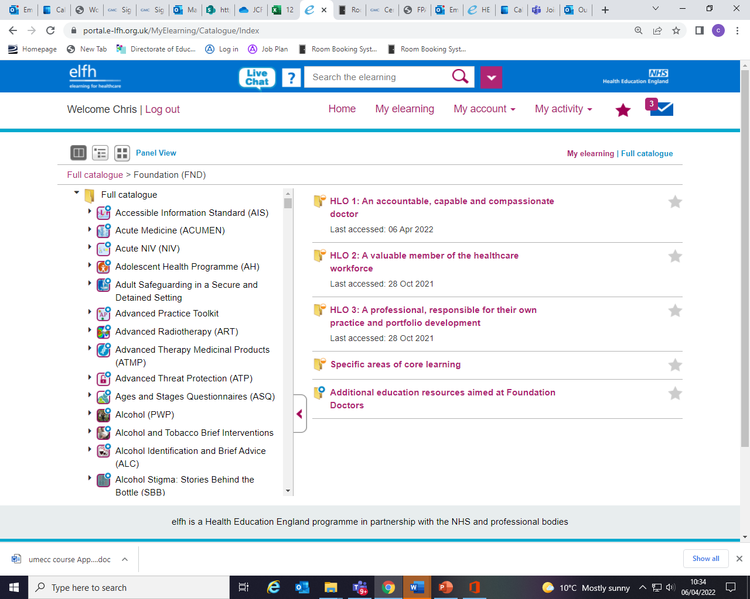
I have listed below the sections in which you will find each part of the e-learning. I have also included the direct links to each session, but some JCF have reported difficulty accessing via the direct links.
I have listed the HLO section and within those sections which FPC section you will find the e-learning in. You can also use the search function.
These are the modules for the induction, you will find many more useful modules for your learning within the foundation section and in other areas of e-learning for health. These will earn you CPD points.
Week | e-learning modules |  | Link | HLO section | FPC Section
1 | Admission | Medical history taking and prescribing on admission | https://portal.e-lfh.org.uk/LearningContent/Launch/698804 | HLO1 | FPC1
 |  | Selection of investigations | https://portal.e-lfh.org.uk/LearningContent/Launch/700423 | HLO1 | FPC1
 |  | Interpretation of investigations | https://portal.e-lfh.org.uk/LearningContent/Launch/700427 | HLO1 | FPC1
 | Handover | Good handover practice | https://portal.e-lfh.org.uk/LearningContent/Launch/700587 | HLO1 | FPC5
2 | Patient care | Keeping the patient at the centre of care | https://portal.e-lfh.org.uk/LearningContent/Launch/700635 | HLO1 | FPC5
 |  | Seeing the whole picture | https://portal.e-lfh.org.uk/LearningContent/Launch/700639 | HLO1 | FPC5
 |  | Effective referrals to other teams | https://portal.e-lfh.org.uk/LearningContent/Launch/630224 | HLO1 | FPC5
3 | Discharge | Multidisciplinary discharge planning | https://portal.e-lfh.org.uk/LearningContent/Launch/700479 | HLO1 | FPC5
4 | IV fluids | NICE IV fluid assessment | https://portal.e-lfh.org.uk/LearningContent/Launch/700499 | HLO1 | FPC1
 |  | NICE IV fluid principles | https://portal.e-lfh.org.uk/LearningContent/Launch/700503 | HLO1 | FPC1
 |  | NICE IV fluid properties | https://portal.e-lfh.org.uk/LearningContent/Launch/700507 | HLO1 | FPC1
 |  | NICE IV fluid more complex scenarios | https://portal.e-lfh.org.uk/LearningContent/Launch/700511 | HLO1 | FPC1
 |  | NICE IV Fluid- when it goes wrong | https://portal.e-lfh.org.uk/LearningContent/Launch/700515 | HLO1 | FPC1
5 | Prescribing | Prescription writing | https://portal.e-lfh.org.uk/LearningContent/Launch/700519 | HLO1 | FPC1
 |  | BNF and other prescribing information sources | https://portal.e-lfh.org.uk/LearningContent/Launch/700523 | HLO1 | FPC1
 |  | Safe prescribing in renal impairment | https://portal.e-lfh.org.uk/LearningContent/Launch/616648 | HLO1 | FPC1
6 | Mental Health/ capacity | Mental health act | https://portal.e-lfh.org.uk/LearningContent/Launch/700351 | HLO1 | FPC1
 |  | Best interests | https://portal.e-lfh.org.uk/LearningContent/Launch/700855 | HLO1 | FPC1
 |  | Restraint | https://portal.e-lfh.org.uk/LearningContent/Launch/700859 | HLO1 | FPC1
 |  | Deprivation of Liberty | https://portal.e-lfh.org.uk/LearningContent/Launch/700863 | HLO1 | FPC1
 |  | Assessing mental capacity | https://portal.e-lfh.org.uk/LearningContent/Launch/700847 | HLO1 | FPC1
7 | Safety | Safe practice a doctor's perspective | https://portal.e-lfh.org.uk/LearningContent/Launch/700371 | HLO1 | FPC1
 |  | Medical error: when things go wrong | https://portal.e-lfh.org.uk/LearningContent/Launch/700375 | HLO1 | FPC1
 |  | Errors and experiences in healthcare | https://portal.e-lfh.org.uk/LearningContent/Launch/704820 | HLO1 | FPC2
 |  | Learning from complaints | https://portal.e-lfh.org.uk/LearningContent/Launch/700879 | HLO1 | FPC2
8 | Communication | Communication skills | https://portal.e-lfh.org.uk/LearningContent/Launch/700399 | HLO1 | FPC4
 |  | Breaking bad news | https://portal.e-lfh.org.uk/LearningContent/Launch/700403 | HLO1 | FPC1
 |  | Cultural and religious diversity and bereavement | https://portal.e-lfh.org.uk/LearningContent/Launch/700411 | HLO1 | FPC1
9 | Information Governance | Confidentiality and privacy | https://portal.e-lfh.org.uk/LearningContent/Launch/700431 | HLO1 | FPC1
10 | Avoiding complaints | Senior advice: when where and how | https://portal.e-lfh.org.uk/LearningContent/Launch/700575 | HLO1 | FPC2
 |  | Senior advice: when to stop for help | https://portal.e-lfh.org.uk/LearningContent/Launch/700579 | HLO1 | FPC2
 |  | How to avoid the GMC disciplinary committee | https://portal.e-lfh.org.uk/LearningContent/Launch/700755 | HLO1 | FPC2
11 | SLEs | Making best use of Muiltsource Feedback | https://portal.e-lfh.org.uk/LearningContent/Launch/706197 | HLO2 | FPC10
 |  | Getting the most out of DOPs | https://portal.e-lfh.org.uk/LearningContent/Launch/706201 | HLO2 | FPC10
 |  | Getting the most from CBDs | https://portal.e-lfh.org.uk/LearningContent/Launch/706205 | HLO2 | FPC10
 |  | Getting the most from minicex | https://portal.e-lfh.org.uk/LearningContent/Launch/706209 | HLO2 | FPC10
 |  | Getting the most from SLEs : feedback and reflection | https://portal.e-lfh.org.uk/LearningContent/Launch/706213 | HLO2 | FPC10
 |  | Getting the most from SLEs: reflection after feedback | https://portal.e-lfh.org.uk/LearningContent/Launch/706217 | HLO2 | FPC10
12 | Appraisal | Priming appraisal ( learning hub) | https://elht-learninghub.co.uk/course/view.php?id=2481

Appendix H: How to use OneDrive so you can share your SLEs and meeting records with your supervisor.
- Open your email and click on the matrix of dots as circled in red below
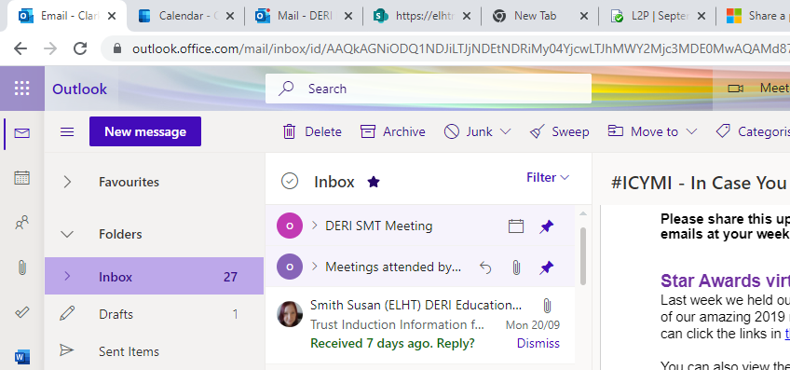
- Select the OneDrive app
- Click on “New” and then select “Folder” from the drop down menu
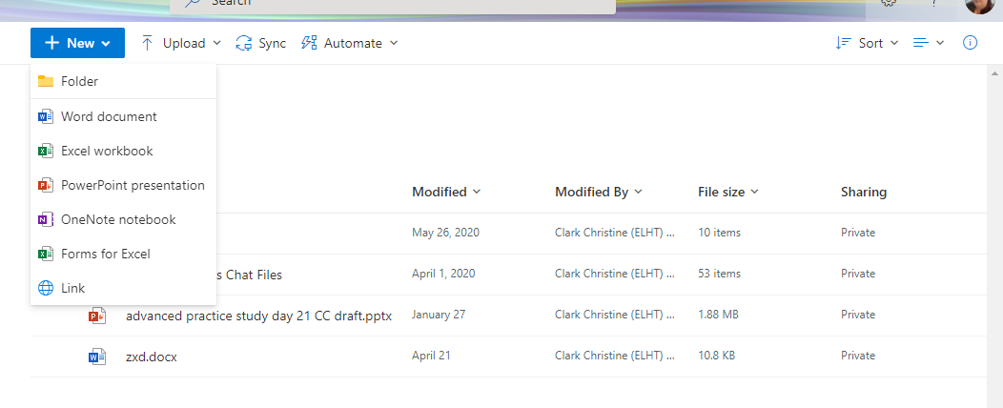
- Name your folder. Include your name in the title. Click create and it will make a folder
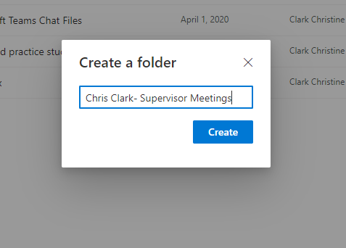
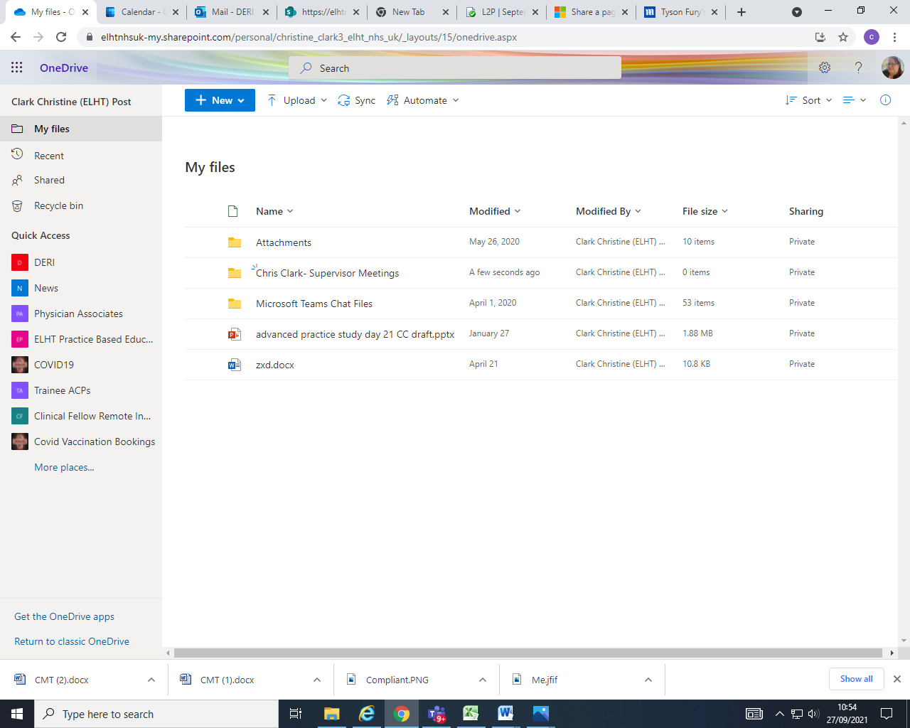
- To share with your supervisor click where it says private next to your folder. They can then view and edit any files within that folder. They will receive an email notification. “Private” will change to “Shared”

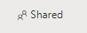

- To remove editing privileges click on the “Shared” icon and select the person’s name. Click on the pencil and select “Can View”
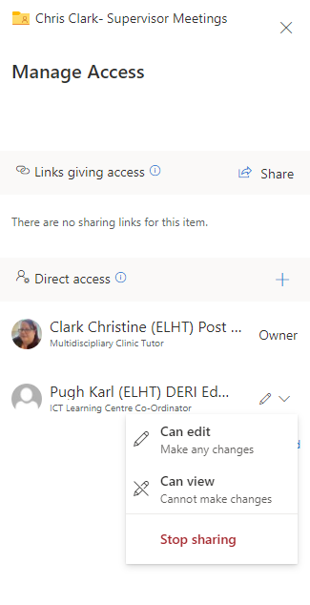
- Upload any SLE forms and copies of records of supervisor meetings to this folder so they can be shared with your supervisor. How you arrange the files is completely up to you but it should be easily navigated by your supervisor
- The folder should be open during supervisor meetings so they can check progress.

Appendix I: Useful Contacts

Dr Chris Clark, Education Lead for Junior Clinical Fellows
Christine.clark3@elht.nhs.uk
Contact via Teams

Post Graduate Office (Shabana Ahmed & Karen Gosling)
PGME@elht.nhs.uk
Tel 01254 733233 ext. 82333 (Karen)
Tel 01254 732313 ext. 82313 (Shabana)

