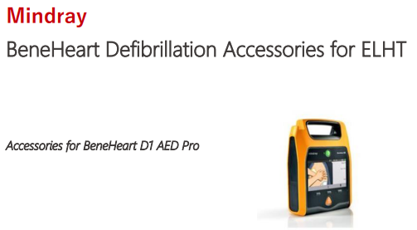
Order direct from Mindray
Item Description | Part Number
Defibrillator Electrode 1 x set 5 Multifunction Defibrillator Pads Adult Disposable non Auto ID For BeneHeart D3 and D1 Defibrillators | 0651-30-77007
Defibrillator Electrode 1 x set 5 Multifunction Defibrillator Pads Paediatric Disposable non Auto ID For BeneHeart D3 and D1 Defibrillators | 0651-30-77008

Or order from NHS Supply Chain
Item Description | Part Number | Supply Chain Code
Defibrillator Electrode 1 x set 5 Multifunction Defibrillator Pads Adult Disposable non Auto ID For BeneHeart D3 and D1 Defibrillators | 0651-30-77007 | FDK1242
Defibrillator Electrode 1 x set 5 Multifunction Defibrillator Pads Paediatric Disposable non Auto ID For BeneHeart D3 and D1 Defibrillators | 0651-30-77008 | FDK1243

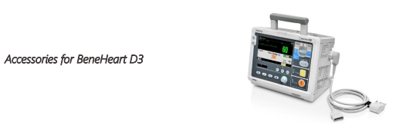
Order direct from Mindray
Item Description | Part Number
Defibrillator Electrode 1 x set 5 Multifunction Defibrillator Pads Adult Disposable non Auto ID For BeneHeart D3 and D1 Defibrillators | 0651-30-77007
Defibrillator Electrode 1 x set 5 Multifunction Defibrillator Pads Paediatric Disposable non Auto ID For BeneHeart D3 and D1 Defibrillators | 0651-30-77008
Microstream CO2 Kit, Adu, | 6800-30-50619
1x CO2 Adapter | 045-003134-00
1x Thermal Recorder Paper | A30-000001---

Or order from NHS Supply Chain
Item Description | Part Number | Supply Chain Code
Defibrillator Electrode 1 x set 5 Multifunction Defibrillator Pads Adult Disposable non Auto ID For BeneHeart D3 and D1 Defibrillators | 0651-30-77007 | FDK1242
Defibrillator Electrode 1 x set 5 Multifunction Defibrillator Pads Paediatric Disposable non Auto ID For BeneHeart D3 and D1 Defibrillators | 0651-30-77008 | FDK1243

