Training and Development Centre, BGTH – Accessibility Photos.

Please be aware that there is no lift access to the first floor and no disabled toilet.

Front Door
- To open the door, you pull.
- To exit the door, you push.
- The door is double (left side is locked).
- There is a bell/buzzer to press on the right hand side.
- The height of the door is 77 inches = 195.58cm.
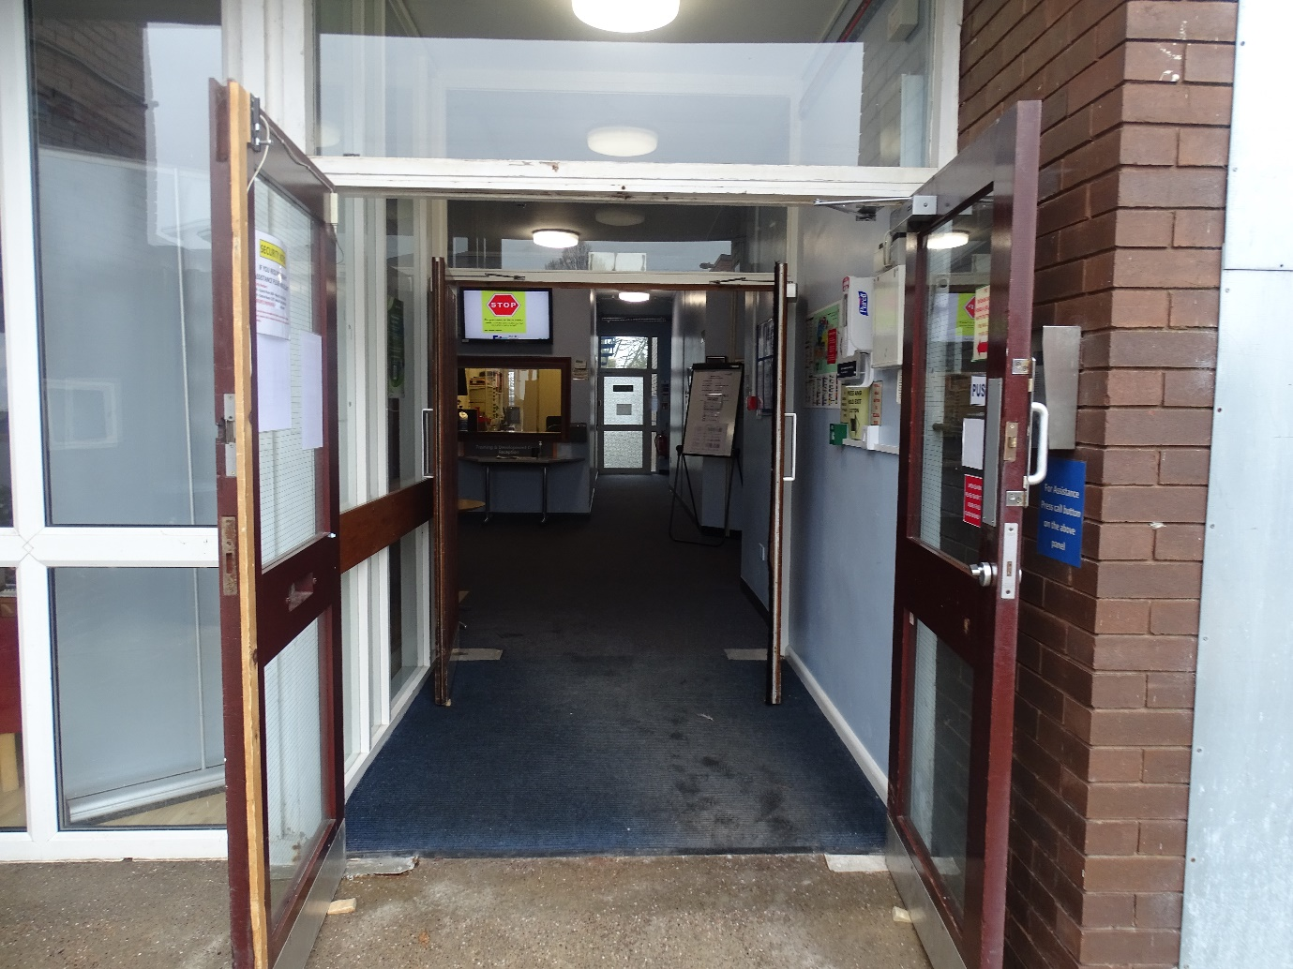
- The width of the door is 66.5 inches = 168.91cm.

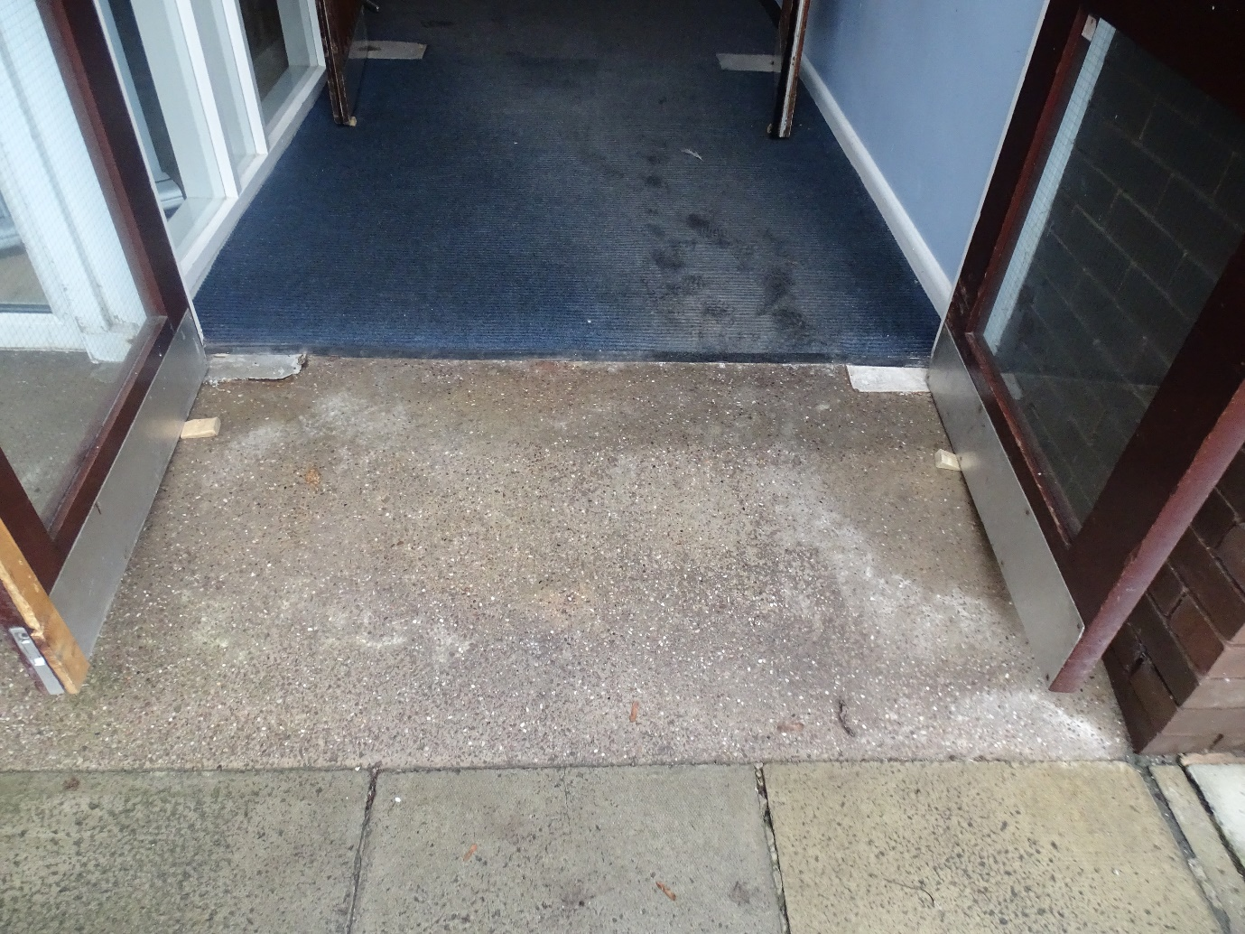
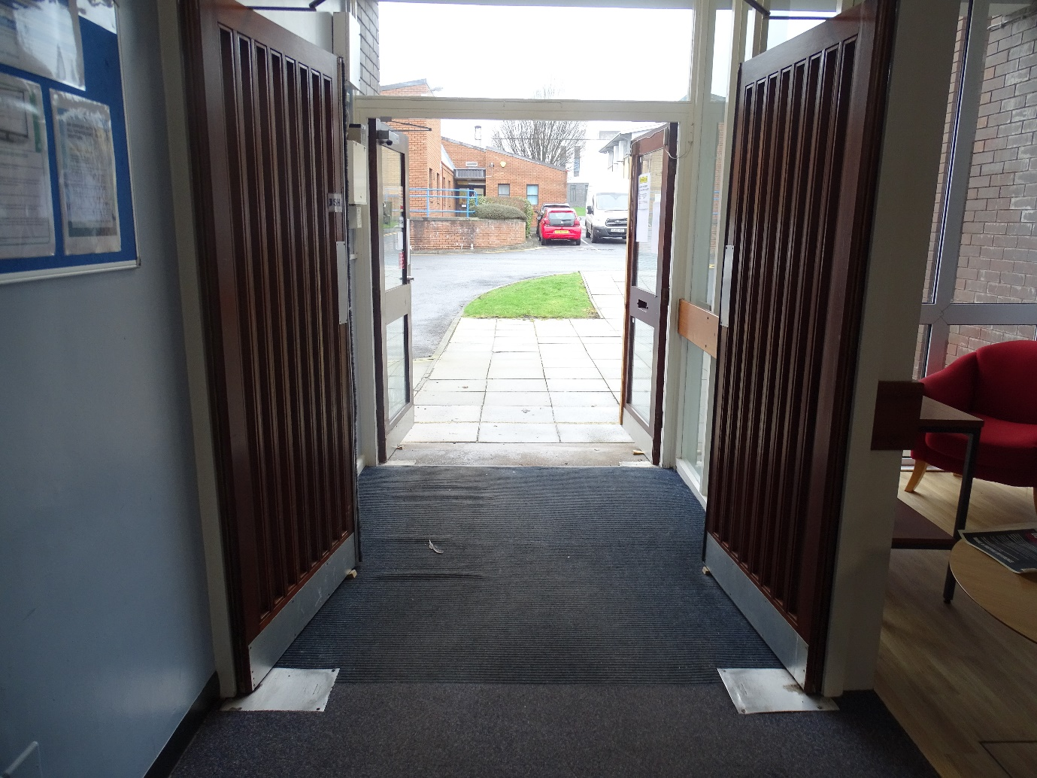

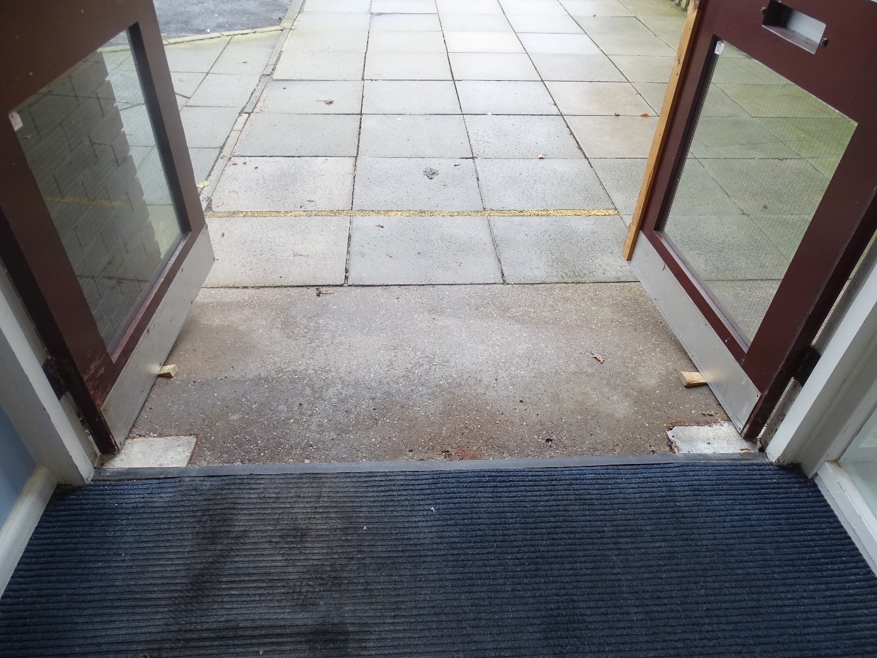

Stairs
- There is 18 steps.
- From to floor to the step –
- Height = 7.5 inches = 19.05cm
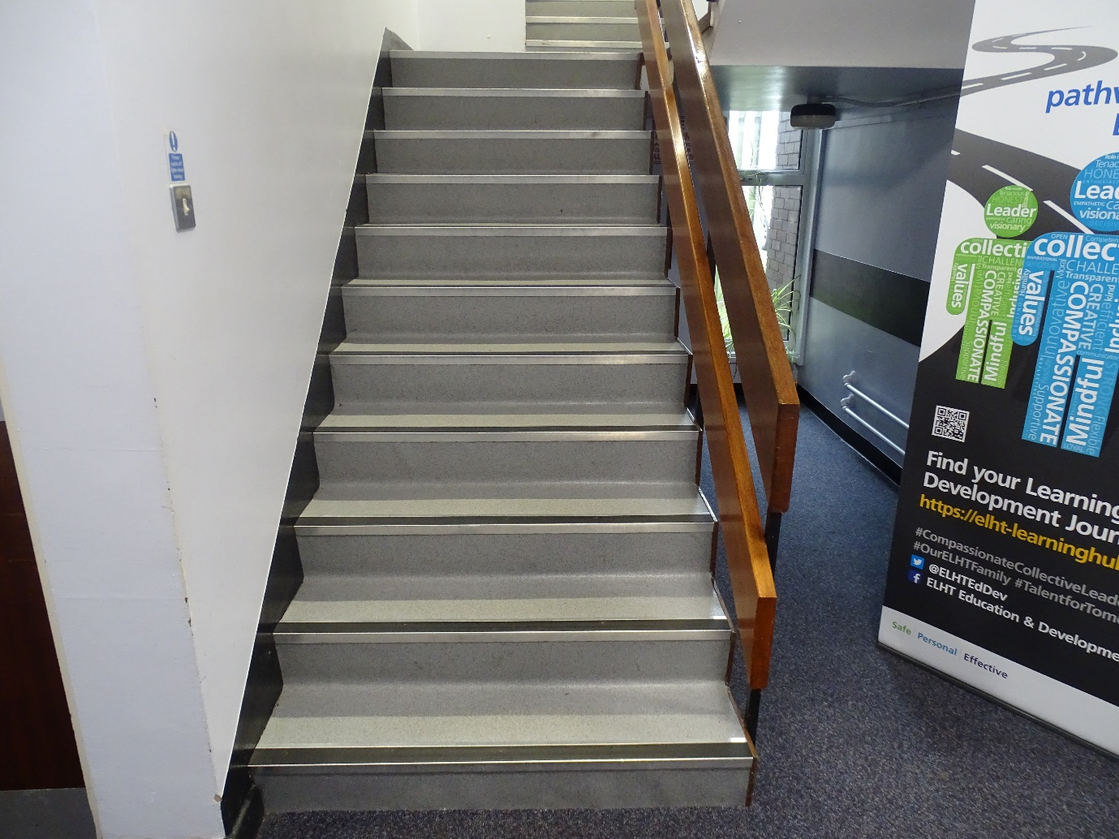
- Width = 4 inches = 10.16cm

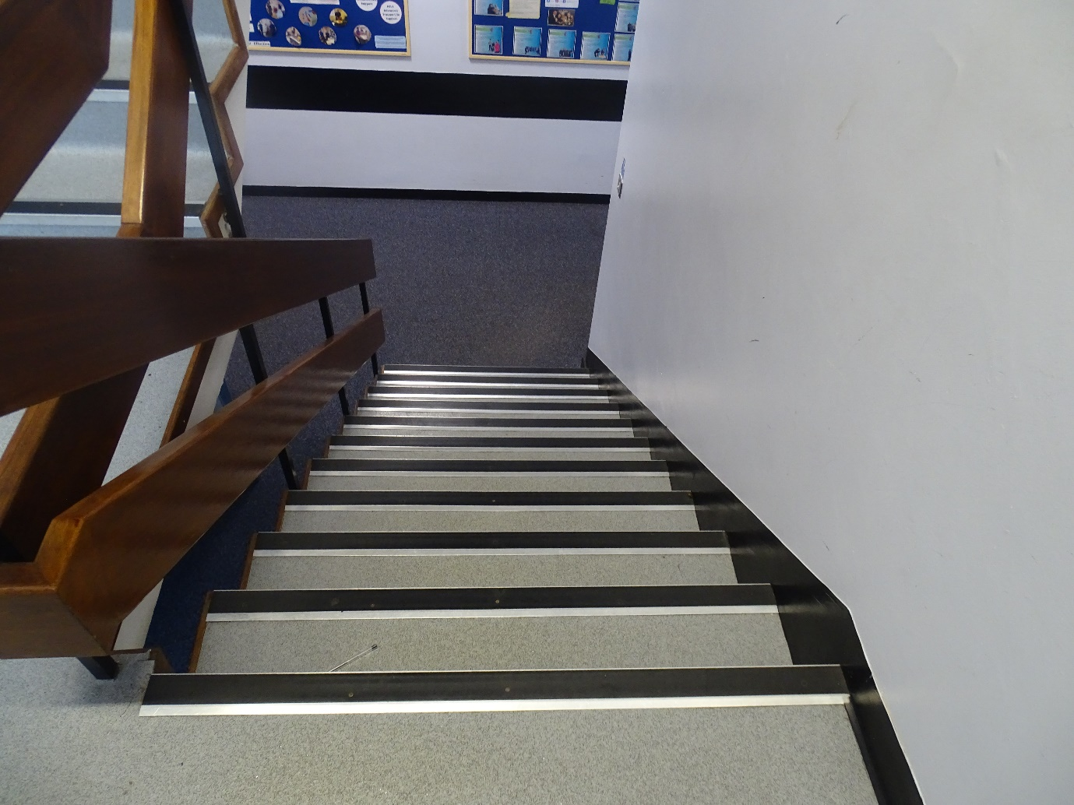
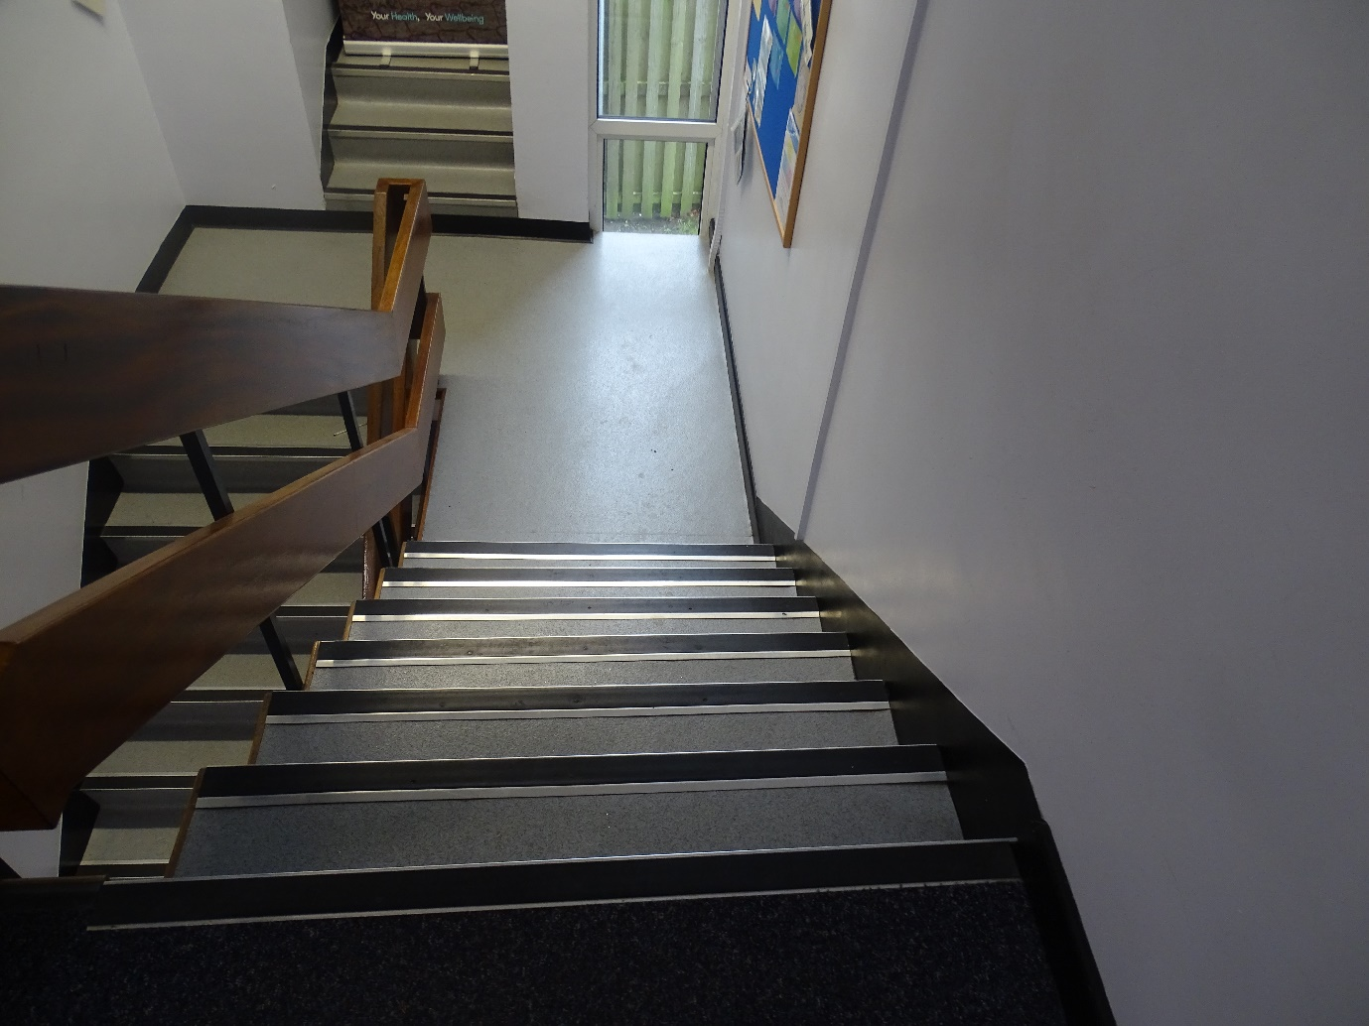
Gents Toilets
- The height is 77 inches = 195.58cm
- The width is 32 inches = 81.28cm
- When entering the toilet, push the door.
- When exiting the toilet, pull the door.
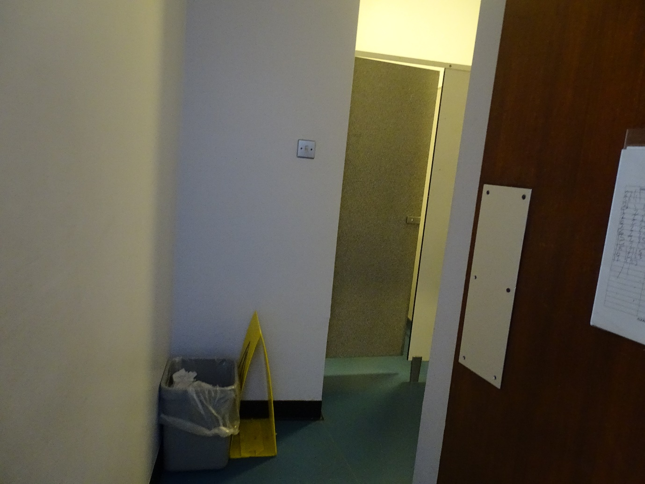
- It is located on the ground floor of the Training and Development Centre.

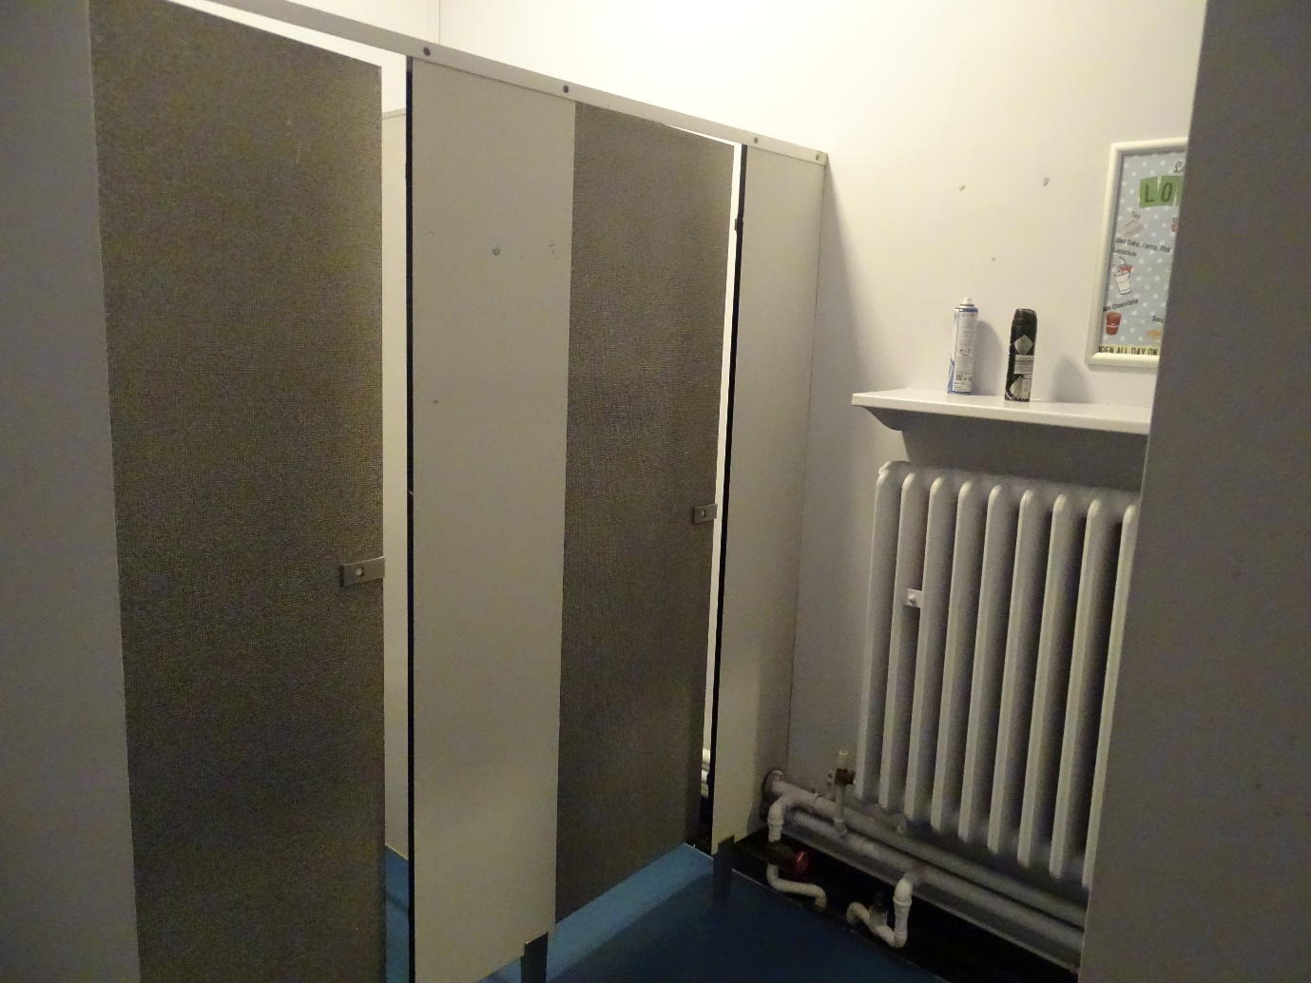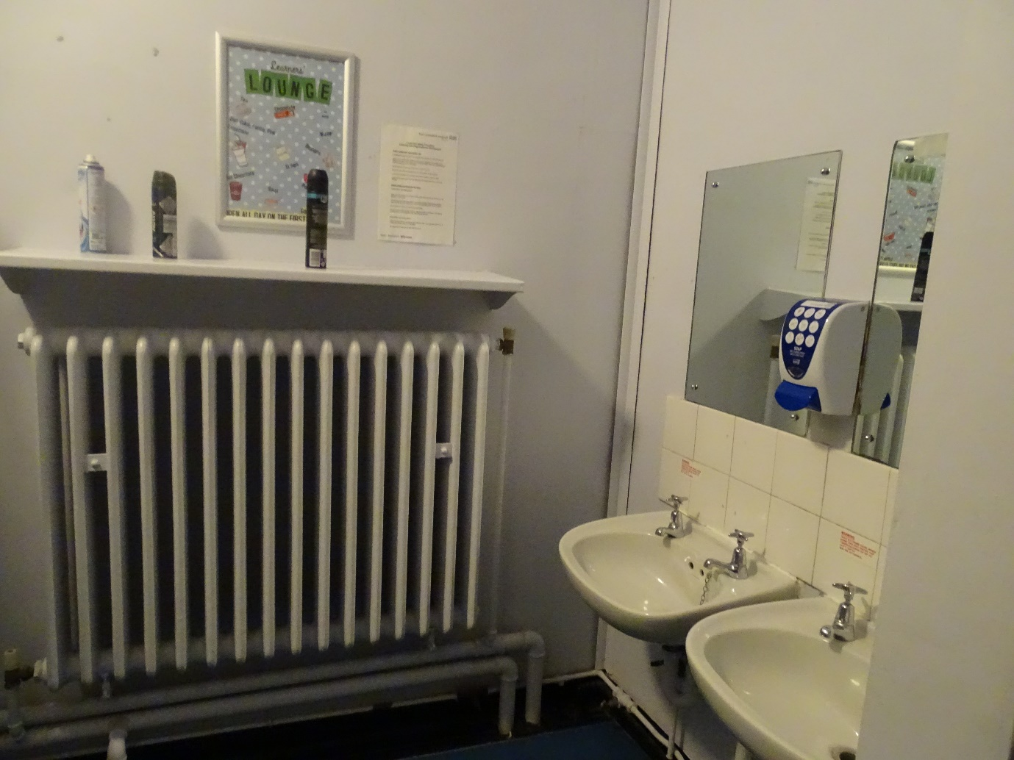
Womens Toilets
- The height is 77 inches = 195.58cm
- The width is 32 inches = 81.28cm
- When entering the toilet, push the door.
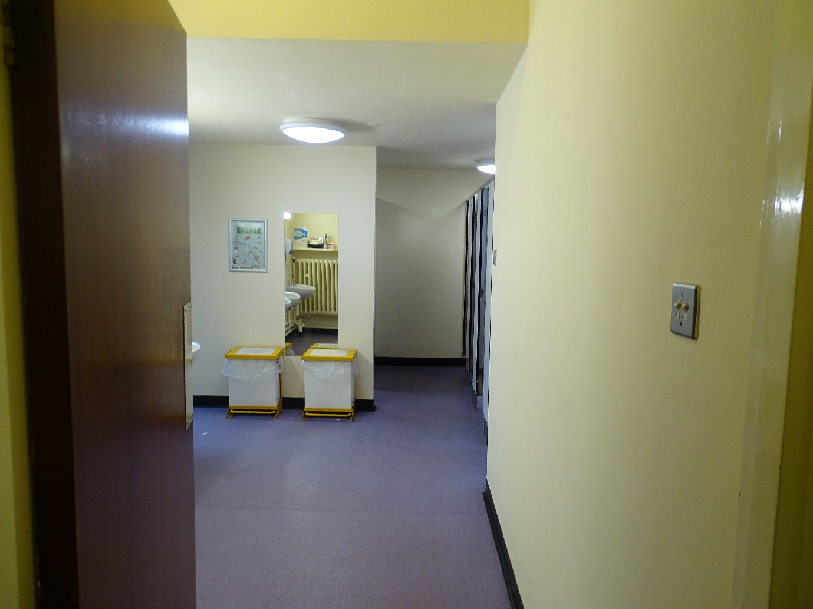
- When exiting the toilet, pull the door.
- It is located on the ground floor of the Training and Development Centre.

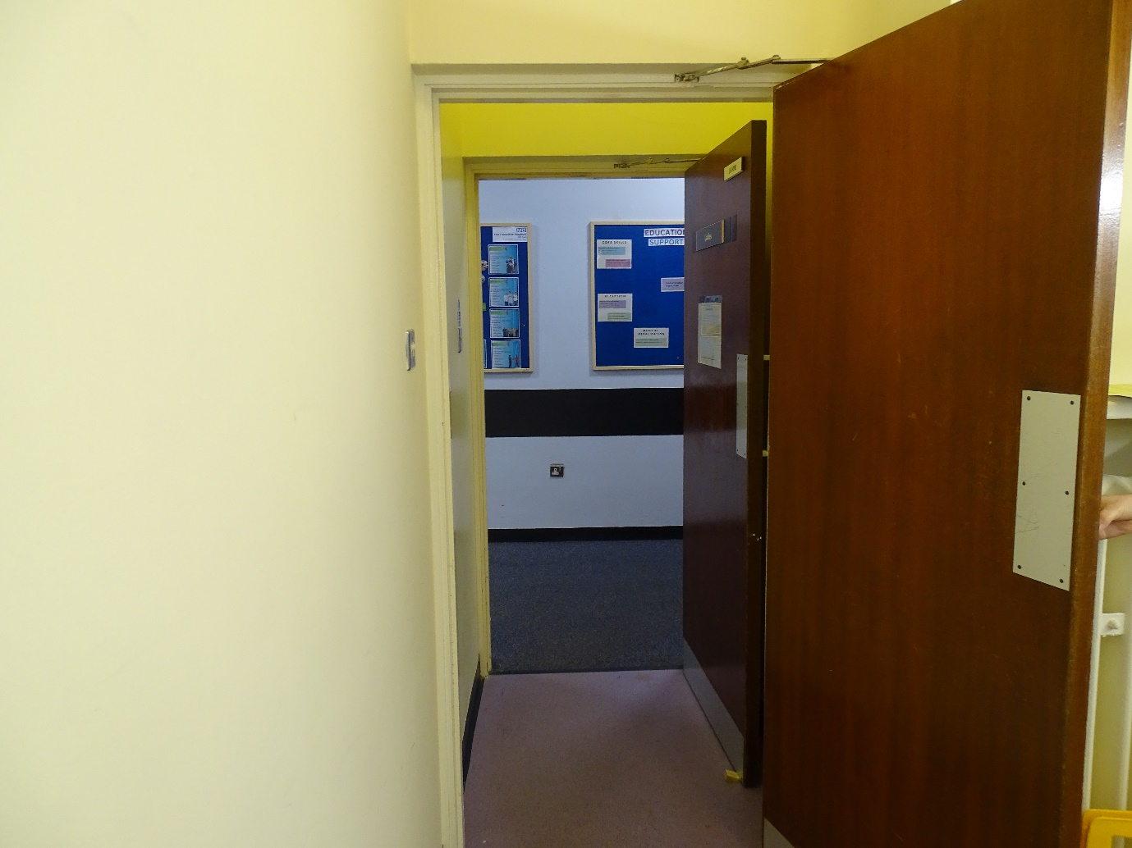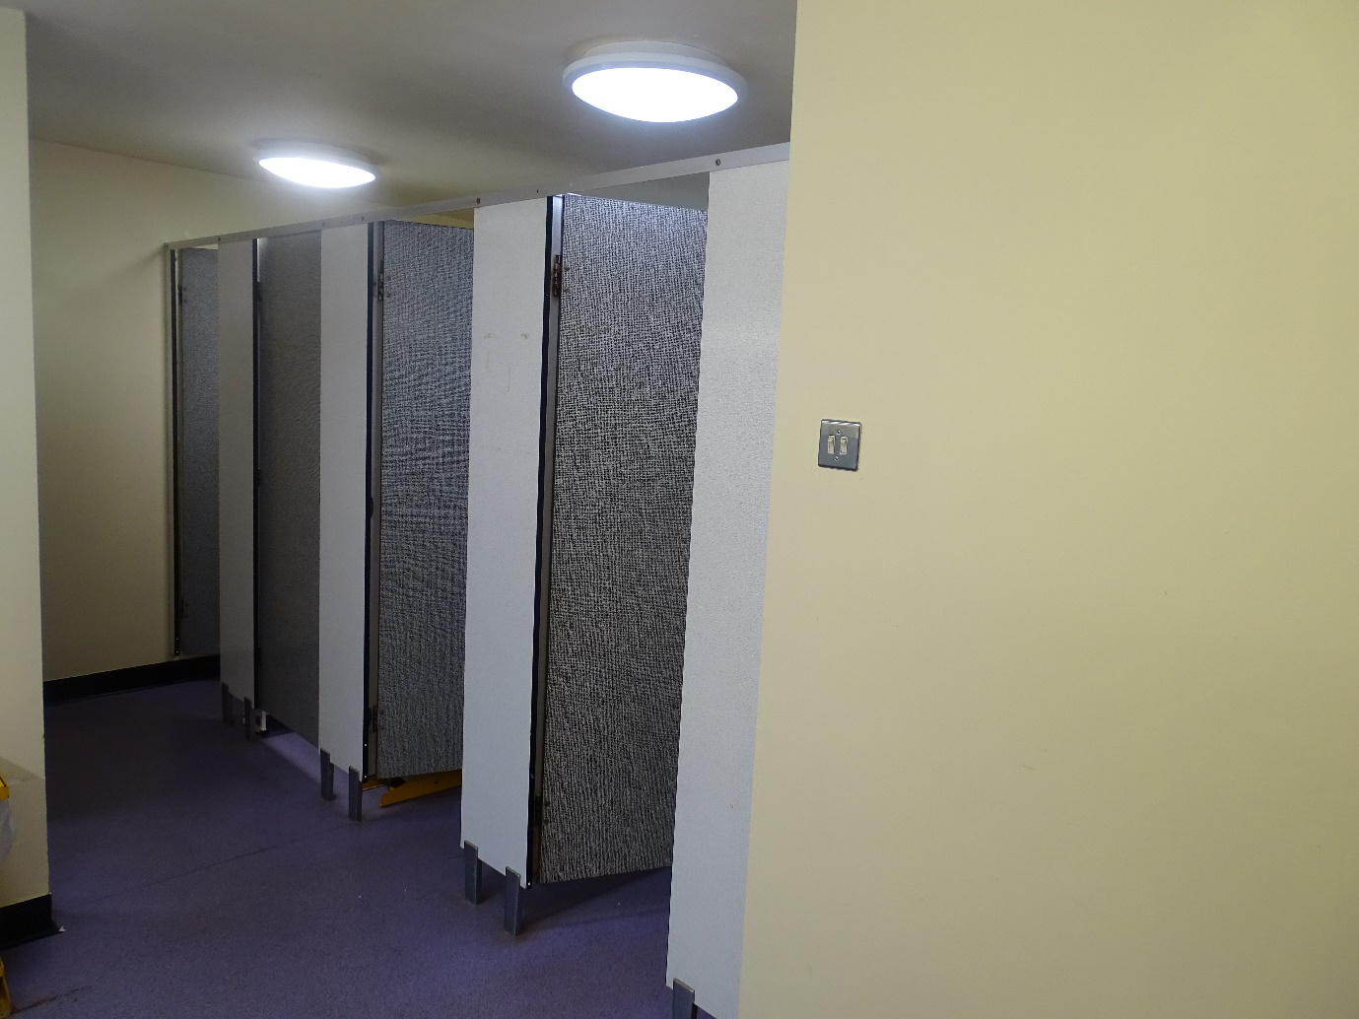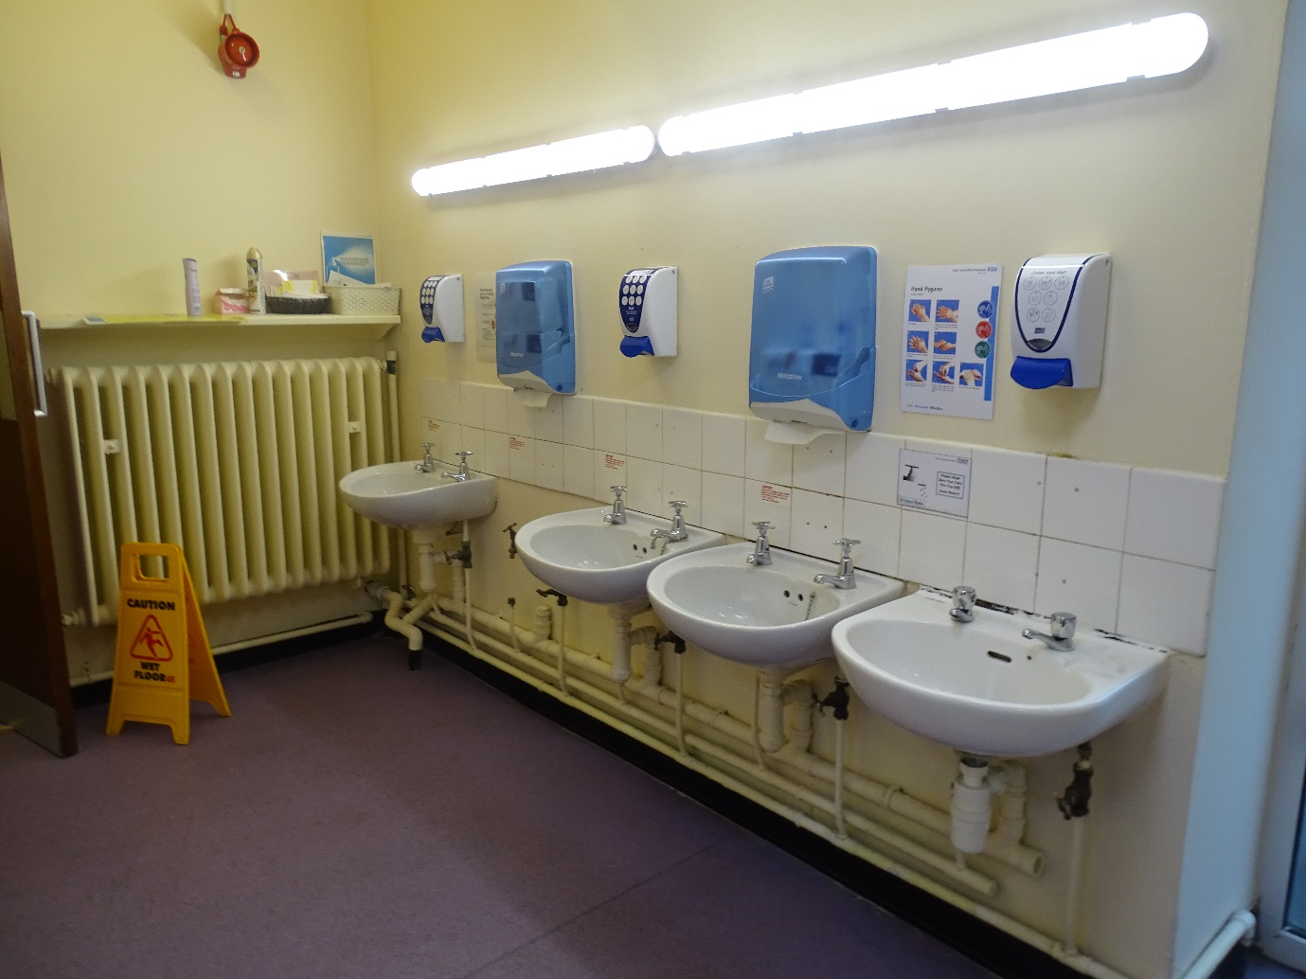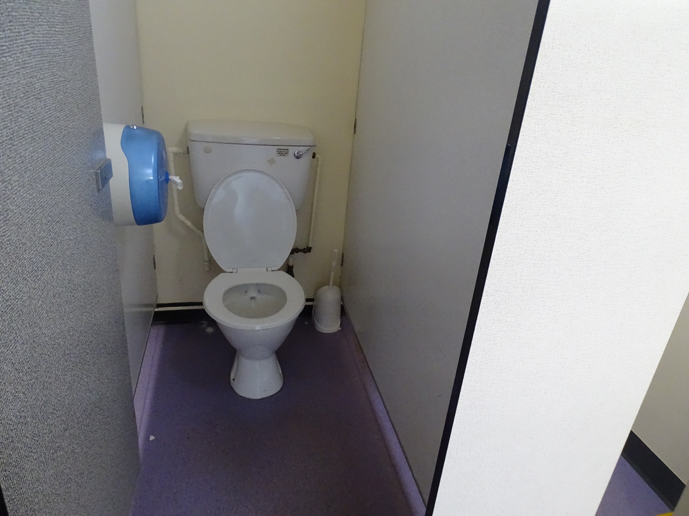
Car Parking
Outside the Training and Development Centre we have two disabled parking spaces for staff/visitors to park in. There is a large gravel car park to the left of the centre for staff. Next to the Training and Development Centre is our Library which occupies some disabled car parking spaces.

